

Summer  
2021

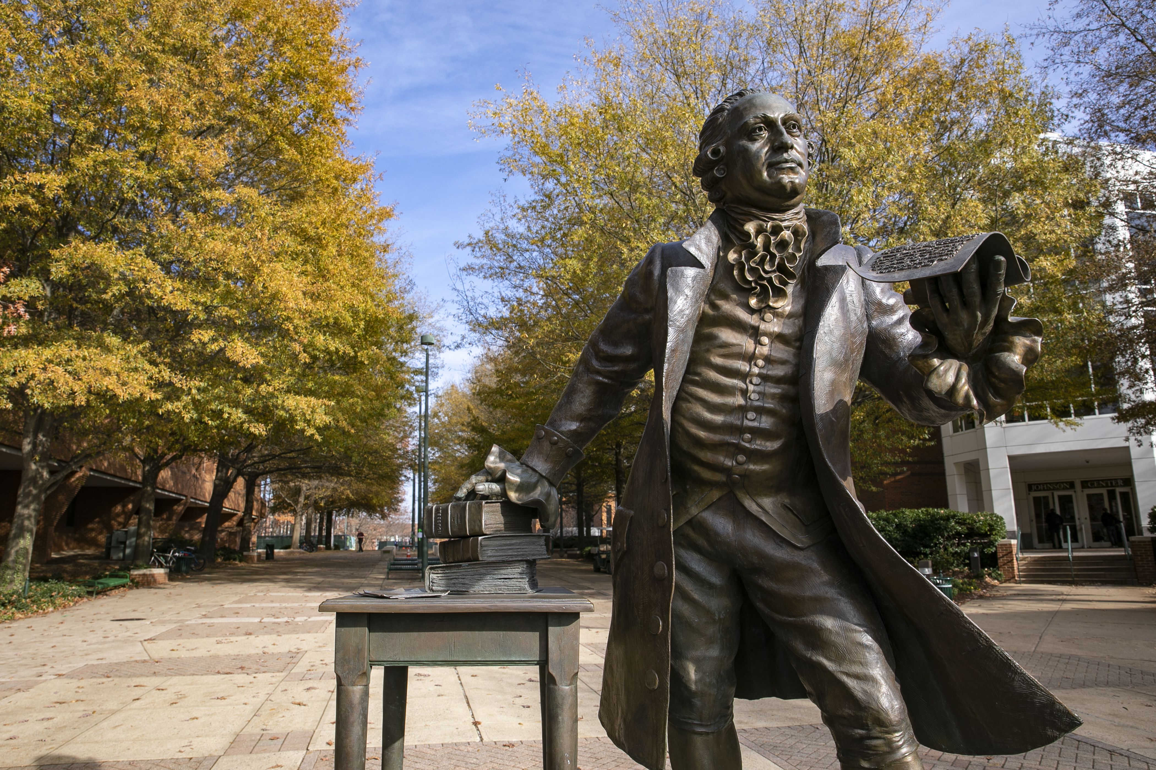

DAEN 690  
Project Report

Matt Talarico, Max Waldron, and Scot Wilson

George Mason University

8/1/2021

**Using Machine Learning to Categorize Occurrence Data**

**This Page Intentionally Left Blank**

**T**able of Contents

Abstract 3

1 Introduction 4

1.1 Background 4

1.2 Problem Space 4

1.3 Research 4

1.4 Solution Space 4

1.5 Project Objectives 4

1.6 Primary User Story (-ies): 5

1.7 Product Vision - Sample scenarios (why would someone want to use this) 5

Scenario #1 5

Scenario #2 5

1.8 Definition of Terms: 5

2 Data Acquisition 6

2.1 Overview: 6

2.2 Field Descriptions: 6

2.3 Data Context: 6

2.4 Data Conditioning 6

2.5 Data Quality Assessment: 7

2.6 Other Data Sources 7

3 Analytics and Algorithms 7

4 Visualization 7

5 Findings 7

6 Summary 7

7 Future Work 7

8 Appendix A: Code References 8

9 Appendix B: Risk Section 9

10 Appendix C: Agile Development 10

11 References 11

# Abstract

**Using Machine Learning to Categorize Occurrence Data**

The FAA (Federal Aviation Association) is the organization that maintains the aviation world under the Department of Transportation. Multiple divisions operate under the FAA’s authority and a large number of those operations could be generalized as aircraft operations. Aircrafts frequently experience or observe a wide array of recordable events (malfunctions, failures, defects, etc.) during the various stages of operation. Critical information concerning these events are recorded on SDR (Service Difficulty Report) reports. Accurately classifying these events into different, yet similar categories can help establish benchmarks and provide insight into industry trends. Today, SDRs are manually processed and assigned a unique code based on the information contained in the report.

The mission is to create a machine learning model to generate correct JASC (Joint Aircraft System/Component Code) codes for future reports based on the fields contained within the SDRs. Trial and error experiments were conducted to find which fields carried the most influence over the different JASC codes. After determining the significant fields, models were created attempting to maximize accuracy and overall performance.

The project produced several noteworthy findings. The unbalanced nature of JASC Code occurrences results in several codes being much more difficult to predict, especially codes that are most infrequently used. Some codes appear to comingle with other codes and lack enough distinguishing features in order to accurately differentiate between other codes, thus providing instances of inaccurate predictions. Moving forward, the FAA team may use insights from this project to amend SDR report standards and procedures that improve classification accuracy. In addition, models could be used to identify or flag SDRs failing to meet a given threshold of prediction confidence, effectively decreasing human resource demand, and improving resource allocation.

# **Introduction**

## **Background**

The 20th century included several significant inventions and technological advances in our existence. When listed chronologically, the airplane might appear first on the list. On December 17th, 1903, Orville Wright became the first person to accomplish a sustained, self-propelled flight and marked the inception of the aviation age. After only a few years, advancements within the new field led to a Michelin prize and on October 6, 1908, Wilbur Wright (Orville’s brother) made the first flight of more than an hour with a passenger. The Wright biplane was patented in multiple foreign countries as well as in the United States and in 1909 sold his machine to the US government.[1]

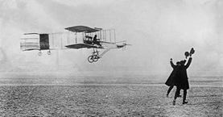[2]

While still in its infancy and developmental stage, the aviation industry’s potential was not lacking in skepticism and uncertainty largely due to its associated danger and risk. Believing the airplane could not reach its full commercial potential without federal action to improve and maintain safety standards, efforts made by aviation industry leaders led to landmark legislation that created a new Aeronautics Branch in the Department of Commerce responsible for aviation oversight. In 1958 the Federal Aviation Act officially initiated the incremental transfer of responsibilities to the Federal Aviation Agency. To improve coordination of a growing transportation system, the 1966 Congress created a cabinet level department called the Department of Transportation (DOT) which combined major federal transportation responsibilities. When the DOT became fully operational on April 1st, 1967, the Federal Aviation Agency was renamed to its current name of the Federal Aviation Administration and is one of many entities that fall under the authority of the U.S. Department of Transportation (DOT).[3]

## **Problem Space**

The FAA’s continuing mission is to provide the safest, most efficient aerospace system in the world. Operating an efficient aviation industry can only be accomplished while operating in a safe aviation industry. In pursuit of that goal, the FAA requires manufactures, airline manufacturers, airline operators, and mechanics to submit reports when observing a malfunction, failure, or defect that meets certain conditions defined by 14 CFR §121.703. These reports are compiled, analyzed, and assigned a Joint Aircraft System/Component (JSAC) code. The JASC codes are organized in a hierarchical structure and can be broken down into nested, parent<<child-like levels where each level provides additional information about specific components and/or systems of aircraft the further the code is drilled down.

**JASC Code Hierarchy**

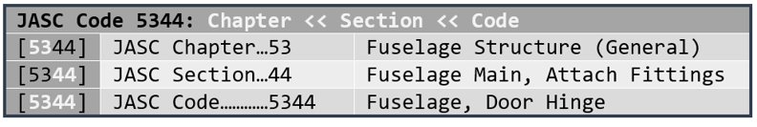

**Common Aircraft Components**

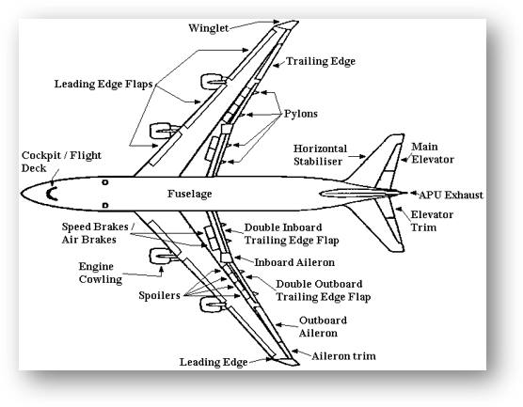

Accurate analysis of this information can yield critical and invaluable insights to the industry. However, it is believed the most valuable piece of the reports lies in the narrative text, or ‘description’ field, which requires vast amounts of human resources to process. Incorporating an automated system that digests and accurately classifies occurrences would improve resource allocation and develop superior safety oversight capabilities.[4]

## **Research**

The project team received the problem description from the FAA and performed web research on the codes and types of maintenance as described by the FAA. The team formulated questions and routinely met with the FAA client team[5] to discuss various topics as they arose and to provide an update on the project status. The FAA provided the project team with a start for the data definitions and further background on the problem. The FAA also provided data from 2019 and the last project team’s findings. While the project team was waiting for information from the FAA the project, we discovered another site for downloading the Service Difficulty Reports based on the customer’s description. The project team also reviewed different types of natural language processing and multi-classification algorithms.

## **Solution Space**

Our system delivers value to its users when it accurately reports a four-digit JASC code from a submitted Service Difficulty Report (SDR). Today, copious amounts of manual effort is required to accurately apply all four digits to a JASC code to identify the aircraft system, component and sub-component identified in the SDR. Users will use the compiled database of JASC codes to improve regulations and maintenance procedures that will improve the safety of the aviation industry. Users internal to the FAA rely on the JASC codes in SDRs to properly identify and assess risks in aircraft system components and sub-components. Users will be able to ascertain the frequency of components by the first two digits of the JASC code and sub-components by the third and fourth digit in the JASC code. Users will also be able to determine the accuracy of aircraft operators in their reports and the airline carriers will be able to compare their maintenance with other airline carriers in the industry.

## **Project Objectives**

There are many objectives and tasks to complete in this project for both our team and our project sponsor. As stated, we are to create a program to decipher JASC codes based on the structured and unstructured input fields given with the intent of using the ‘discrepancy’ field to predict a two-digit JASC Code. When all is said and done, the team would like to have endured a process where we learned the intimate process of assigning JASC codes and how some unstructured data, such as the ‘discrepancy’ field, are up for interpretation since they are dealing with humans own verbiage. For the JASC codes that may be potentially too hard to determine, we would like to understand the reasoning for such. Whether it is from lack of information on the SDR or just too much difference between mechanic reporting styles.

We would also assume to have learned about numerous platforms regarding NLP (Natural language Processing) along with how to implement the right one at the appropriate time. We have researched a few platforms to use that can help us accomplish our project, but it is finding the right one. The benefit we will get in this research is finding the differences between them and how they are effective in different forms. From the granularity we face when assigning JASC codes, we believe we will have created a program to get the first two characters of the 4-digit JASC code with great accuracy. The following two characters will give us a great challenge since you must drill down deeper to find a higher level of word sensitivity for that record.

What we hope to accomplish is utilizing an NLP platform to allow the client to quickly and effectively assign JASC codes based on historically assigned JASC codes in comparison to the fields populated for records. The value this gives to the client is so that they can spend more time analyzing the JASC code’s occurrences and where the team should spend their time. This could navigate where efforts and investments are made to lower the number of problems and JASC occurrences happen overall.

## **Primary User Stories:**

The stories we have generated are specific to the product sponsor’s needs and wants regarding the JASC codes:

*“As a User, I would like the capability to automatically assign the JASC codes for our aircraft vehicles without the constant use of PMIs.”*

*“As a User, I want to have JASC code assigning time back to spend efforts in new decision-based analytical areas.”*

*“As a User, I would like to know that the JASC codes that are being assigned based on NLP and ML are under an explicit degree of certainty.”*

*“As a User, I want to be able to still manually assign JASC codes that do not reach the level of certainty we are expecting in the automation process.”*

## **Product Vision - Sample scenarios (why someone would use this)**

### **Scenario #1**

This product will provide the Service Difficulty Reporting System (SDRS) program of the FAA an automated and accurate assignment of JASC codes on submitted SDRs from airline carriers.  Once submitted, the SDRS program will be able to provide analytical tools for the rest of the FAA and external stakeholders to leverage the data to improve regulations, policy, and establish best practices.  The data submitted was only analyzed for SDR submissions and other types of reports could be considered.  The value for the SDR program is shifting workflow from manually reviewing and assigning a JASC code toward higher value activities such as verification and utilization of the code for stakeholders inside and outside the FAA.  The JASC code becomes a key piece of metadata the SDRS program can use to build information products to improve airline safety and practices.  The assignment of the 4-digit code may be limited by the amount of information and the quality of SDR reports used to train the model.

### **Scenario #2**

This product will provide Aircraft Certification office of the FAA with a metadata label assigned to each submitted report from an airline operator. The metadata indicates the aircraft system, component and sub-component that had a maintenance activity.  Understanding the occurrence of a maintenance activity at the sub-component level for each type of aircraft allows the Aircraft Certification office to adjust processes and procedures airline carriers use to certify their aircraft for operation. Reliable metadata and accurate information are crucial to determining what aircraft certification requirements need to be in place.  The metadata label is not sufficient to determine severity of the maintenance.  Also, the maintenance report or SDR may address the initial cause and a supplemental report may indicate the actual root cause.

### **Scenario #3**

This product will provide critical frequency of maintenance records on aircraft system and components for the Aircraft Safety Office of the FAA. The value is the ability to calculate risk of aircraft system, component, and sub-component failures based on the combination of frequency and severity. The Safety Office uses the assignment of a JASC code in the maintenance report as an indication of frequency and severity.  The product of severity and frequency indicates the level of risk.  As the Safety Office recognizes higher level of risk in specific components the FAA can mitigate the increased risk by providing airline carriers updated regulations and policy.  One caveat is the actual likelihood of parts failing is not accounted for with this product. Also, this product does not assume any accuracy in terms of the maintenance activity or preventative activity will have on future occurrences of an SDR.

## **Definition of Terms**

* **121.703**: Administrative law regarding Service Difficulty Reporting for aircraft operators falling under part 121.
* **135.415**: Administrative law regarding Service Difficulty Reports for aircraft operators falling under part 135.
* **Airline Carriers**: The companies which own and operate commercial aircraft for the transportation of people and/or cargo under the regulation of the FAA.
* **Airworthiness Certification**: An FAA approval to operate an aircraft.
* **FAA:** Federal Aviation Administration.
* **JASC**: Joint Aircraft System/Component.
* **JASC Code**: This is an up to 4-digit code assigned by the FAA or airline carrier to any submitted maintenance report. The code belongs to 51 different 2-digit codes indicating the system and a subsequent digit to indicate the component and where applicable a fourth digit to indicate the sub-component.
* **NLP:** Natural Language Processing. The automatic manipulation of natural language, speech, and text, using software.
* **Part 121**: Federal Aviation Regulations (FAR) Part 121 Certification allows a company to act as a scheduled airline. Part 121 is required for carriers who are transporting larger numbers of passengers (i.e., a group jet charter).
* **Part 135**: The FAA regulations on certificates, requirements for certification, and the certification process for the operation of on-demand flights and scheduled charter flights. Scheduled charter flights are usually limited to a few days a week.
* **PMI**: This is the principal maintenance inspector that is responsible for overseeing the submission of Service Difficulty Reports from airline carriers.
* **Risk**: Measurement of frequency times severity to calculate the likelihood and impact of an event.
* **SDR**: The airline carriers are responsible to submit a Service Difficulty Report (SDR) when maintenance is performed that contains the relevant information to identify the system/component being repaired.
* **Stemming and Lemmatization**: Methods to determine the root word when performing natural language processing.
* **Stopwords**: Words filtered out of text blocks during text processing; typically, common words with little to no intrinsic value (i.e., a, the, is, etc.).
* **Title 14**: This is a set of rules and regulations issued by the Department of Transportation and Federal Aviation Administration, over the air and space.
* **Wordcloud**: Images that show common words used in a particular chunk of text; the words are sized according to the frequency in which they appear.

# **Data Acquisition**

## **Overview:**

The dataset we worked with originated from the official FAA (Federal Aviation Administration) website. It is accessed using query parameters derived from key fields within SDRs such as JASC code, part, engine, aircraft and most importantly, the date. However, any individual search is limited to a maximum of 1,500 records. Additionally, the export utility only allows up to 1,000 rows at a time and the database contains (roughly) 50,000 records annually so multiple data pulls had to be conducted within smaller time intervals. Initially, three years of data was pulled to start the project. However, after further discussions with the client team, two more years of data was acquired and several additional records were downloaded going back as far as the year 2000 to increase population size across the lesser frequently observed JASC codes. The database records go back to the year 1980, but five years’ worth of data was considered by the client team to provide a thoroughly sufficient and effectively representative sample of the population.

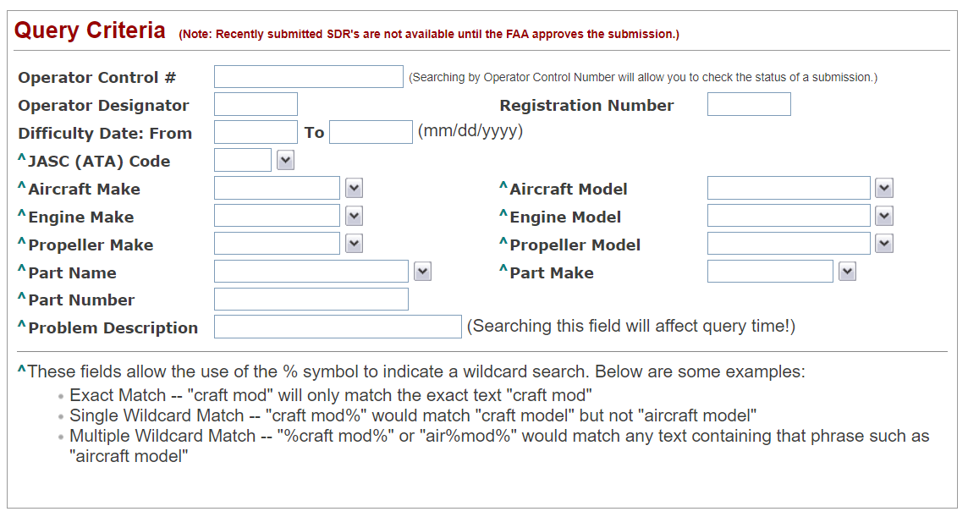

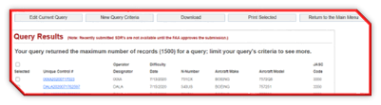

## **Field Descriptions:**

The dataset includes 76 unique columns. Each row represents a single SDR report that include pertinent information relating to that specific SDR. The four-digit number located in the JASCCode field is designated as the target variable. All other attributes represent different fields relating to SDRs. Some of these fields are required by the FAA to submit an SDR, while others are not. Most of the fields are numeric or alpha-numeric codes that have no explicit meaning to individuals outside of the aviation industry.

| Attribute | Data Type1 | Data Type2 | Data Type3 | Data Type4 | Data Type5 | Max Len | Description |
| --- | --- | --- | --- | --- | --- | --- | --- |
| OperatorControlNumber | Qualitative | Categorical | Nominal | String | Varchar | 17 | Unique ID to identify report number, often a concatenation of operator and date fields |
| DifficultyDate | Quantitative | Numeric | Ordinal | DateTime |  |  | Enter the date the problem occurred. The date should be formatted as "mm/dd/yyyy" and cannot be more than five years old or a future date. The year must contain four digits. |
| SubmissionDate | Quantitative | Numeric | Ordinal | DateTime |  |  | Enter the date the SDR report was submitted. The date should be formatted as "mm/dd/yyyy" and cannot be more than five years old or a future date. The year must contain four digits. |
| OperatorDesignator | Qualitative | Categorical | Nominal | String | Varchar | 4 | Designator of the operator of the aircraft. Required unless Submitter Type = ''Z" (Non-Cert International) or SDR Type = "G" |
| SubmitterDesignator | Qualitative | Categorical | Nominal | String | Varchar | 4 | Designator of the company submitting the SDR. May be different from the OperatorDesignator in the case of Repair Stations. |
| SubmitterTypeCode | Qualitative | Categorical | Nominal | String | Char | 1 | Must be a valid Submitter Type Code. Most commercial air carriers have a SubmitterType of "A". |
| ReceivingRegionCode | Qualitative | Categorical | Nominal | String | Char | 2 | Combined with the ReceivingDistrictOffice Code to represent the FAA Region/District Office which certified this air carrier, and which is responsible for monitoring the air carrier's activity (e.g., "GL09" is district office "09" in the "Great Lakes" region). Must be a valid Region Code for the flight Standard Service (AFS) Region that is primarily responsible. |
| ReceivingDistrictOffice | Qualitative | Numeric | Nominal | Integer |  | 2 | Combined with the ReceivingRegion Code to represent the FAA Region/District Office which certified this air carrier, and which is responsible for monitoring the air carrier's activity (e.g., "GL09" is district office "09" in the "Great Lakes" region). Must be a valid District Office Code for the FSDO, CMO, or IFO that is primarily responsible. |
| SDRType | Qualitative | Categorical | Nominal | Char |  | 1 | Must be "G" or "A." "G" means that this is a General Aviation-related SDR; "A" means that this is an Air Carrier-related SDR. No other values will be accepted. |
| JASCCode | Qualitative | Numeric | Ordinal | Integer |  | 4 | The Joint Aircraft System/Component (JASC) Code, previously known as "ATA," code. Must be a valid 4-digit code. |
| NatureOfConditionA | Qualitative | Categorical | Nominal | String | Char | 1 | Must be a valid Nature of Condition Code. |
| NatureOfConditionB | Qualitative | Categorical | Nominal | String | Char | 1 | If given, must be a valid Nature of Condition Code. |
| NatureOfConditionC | Qualitative | Categorical | Nominal | String | Char | 1 | If given, must be a valid Nature of Condition Code. |
| PrecautionaryProcedureA | Qualitative | Categorical | Nominal | String | Char | 1 | Must be a valid Precautionary Procedure Code. |
| PrecautionaryProcedureB | Qualitative | Categorical | Nominal | String | Char | 1 | If given, must be a valid Precautionary Procedure Code. |
| PrecautionaryProcedureC | Qualitative | Categorical | Nominal | String | Char | 1 | If given, must be a valid Precautionary Procedure Code. |
| PrecautionaryProcedureD | Qualitative | Categorical | Nominal | String | Char | 1 | If given, must be a valid Precautionary Procedure Code. |
| StageOfOperationCode | Qualitative | Categorical | Nominal | String | Char | 2 | Must be a valid Stage of Operation Code. |
| HowDiscoveredCode | Qualitative | Categorical | Nominal | String | Varchar | 1 | Must be a valid How Discovered Code. |
| RegistryNNumber | Qualitative | Categorical | Nominal | String | Varchar | 5 | Aircraft Registration Number. Do not include leading "N" for American-registered aircraft. The letters "I" and "O" should never appear in a valid American N-Number. Enter as much of the registration number as possible for non-American-registered aircraft. |
| AircraftMake | Qualitative | Categorical | Nominal | String | Char | 6 | Enter a valid FAA (SIT) Aircraft Make Code. AircraftMake is required. |
| AircraftModel | Qualitative | Categorical | Nominal | String | Varchar | 12 | Enter a valid FAA (SIT) Aircraft Model Code. |
| AircraftSerialNumber | Qualitative | Categorical | Nominal | String | Varchar | 12 | Aircraft Serial Number |
| AircraftTotalTime | Quantitative | Numeric | Ratio | Integer |  | 7 | Total aircraft time in hours. Must be greater than or equal to zero. |
| AircraftTotalCycles | Quantitative | Numeric | Ratio | Integer |  | 6 | Total cycles on aircraft in hours. Must be greater than or equal to zero. |
| EngineMake | Qualitative | Categorical | Nominal | String | Char | 6 | Enter a valid FAA (SIT) Engine Make Code. |
| EngineModel | Qualitative | Categorical | Nominal | String | Varchar | 12 | Enter a valid FAA (SIT) Engine Model Code. |
| EngineSerialNumber | Qualitative | Categorical | Nominal | String | Varchar | 12 | Engine Serial Number |
| EngineTotalTime | Quantitative | Numeric | Ratio | Integer |  | 7 | Total engine time in hours. Must be greater than or equal to zero. |
| EngineTotalCycles | Quantitative | Numeric | Ratio | Integer |  | 5 | Total cycles on engine in hours. Must be greater than or equal to zero. |
| PropellerMake | Qualitative | Categorical | Nominal | String | Varchar | 6 | Enter a valid FAA (SIT) Propeller Make Code. |
| PropellerModel | Qualitative | Categorical | Nominal | String | Varchar | 12 | Enter a valid FAA (SIT) Propeller Model Code. |
| PropellerSerialNumber | Qualitative | Categorical | Nominal | String | Varchar | 11 | Propeller Serial Number |
| PropellerTotalTime | Quantitative | Numeric | Ratio | Integer |  | 7 | Total propeller time in hours. Must be greater than or equal to zero. |
| PropellerTotalCycles | Quantitative | Numeric | Ratio | Integer |  | 6 | Total cycles on propeller in hours. Must be greater than or equal to zero. |
| PartMake | Qualitative | Categorical | Nominal | String | Varchar | 12 | Enter a valid FAA (SIT) Part Make (name of manufacturer) Code. Enter "UNK" if Part Make is unknown. PartMake or PartName is required if the PartNumber is entered. |
| PartName | Qualitative | Categorical | Nominal | String | Char | 17 | Enter name of malfunctioning or detective part which generated reported problem (i.e., skin, rib, shaft, venturi, transistor, capacitor, etc.) Avoid colloquial names. See the "JASC Code, Standard Part Name and Condition" document on the Internet-SDR website (<http://av-info.faa.gov/isdr>) For a list of recommended, standardized part names. PartMake or PartName is required if the PartNumber is entered. |
| PartNumber | Qualitative | Categorical | Nominal | String | Varchar | 16 | Enter the part identifier assigned by the manufacturer. |
| PartSerialNumber | Qualitative | Categorical | Nominal | String | Varchar | 15 | Enter serial number assigned by manufacturer. |
| PartCondition | Qualitative | Categorical | Nominal | String | Char | 16 | Part Condition is required if PartMake or PartName are entered. See the "JASC Code, Standard Part Name and Condition" document for a list of recommended, standardized part conditions. |
| PartLocation | Qualitative | Categorical | Nominal | String | Char | 16 | Part Location |
| PartTotalTime | Quantitative | Numeric | Ratio | Integer |  | 7 | Total part time in hours. Must be greater than or equal to zero. |
| PartTotalCycles | Quantitative | Numeric | Ratio | Integer |  | 6 | Total cycles on part in hours. Must be greater than or equal to zero. |
| PartTimeSince | Quantitative | Numeric | Ratio | Integer |  | 6 | Time part has been in service since its most recent overhaul, repair or inspection. May not be greater than PartTotalTime. PartTimeSince is required if PartSinceCode is entered. |
| PartSinceCode | Qualitative | Categorical | Nominal | String | Char | 1 | Identifies whether the ComponentTimeSince indicates the time since the component was overhauled, inspected or repaired. If given, must be "O" for Overhaul, "R" for Repair, or "I" for Inspection. PartSinceCode is required if PartTimeSince is entered. |
| ComponentMake | Qualitative | Categorical | Nominal | String | Char | 12 | Enter a valid FAA (SIT) Component Make (name of manufacturer) Code if Component Part Number is entered. Enter "UNK" if component make is unknown. ComponentMake or ComponentName is required if the ComponentPartNumber is entered. |
| ComponentModel | Qualitative | Categorical | Nominal | String | Varchar | 12 | Enter model number assigned by the component manufacturer. |
| ComponentName | Qualitative | Categorical | Nominal | String | Varchar | 15 | Enter the name given to the component by its manufacturer. ComponentMake or ComponentName is required if the ComponentPartNumber is entered. |
| ComponentPartNumber | Qualitative | Categorical | Nominal | String | Varchar | 20 | Enter component manufacturer's part number. |
| ComponentSerialNumber | Qualitative | Categorical | Nominal | String | Varchar | 12 | Enter serial number assigned by component manufacturer. Do not repeat "Major Equipment Identity" in this location. |
| ComponentLocation | Qualitative | Categorical | Nominal | String | Varchar | 20 | Component Location |
| ComponentTotalTime | Quantitative | Numeric | Ratio | Integer |  | 6 | Total component time in hours. Must be greater than or equal to zero. |
| ComponentTotalCycles | Quantitative | Numeric | Ratio | Integer |  | 5 | Total cycles on component. Must be greater than or equal to zero. |
| ComponentTimeSince | Quantitative | Numeric | Ratio | Integer |  | 6 | Time component has been in service since its most recent overhaul, repair, or inspection. May not be greater than ComponentTotalTime. ComponentTimeSince is required if ComponentSinceCode is entered. |
| ComponentSinceCode | Qualitative | Categorical | Nominal | String | Char | 1 | Identifies whether the ComponentTimeSince indicates the time since the component was overhauled, inspected, or repaired. If given, must be "O" for Overhaul, "R" for Repair, or "I" for Inspection. ComponentSinceCode is required if ComponentTimeSince is entered. |
| FuselageStationFrom | Quantitative | Numeric | Ratio | Float* |  | 12 | The number of the fuselage station at which an identified structural problem begins |
| FuselageStationTo | Quantitative | Numeric | Ratio | Float* |  | 12 | The number of the fuselage station at which an identified structural problem ends |
| StringerFrom | Quantitative | Numeric | Ratio | Float* |  | 11 | The number of the stringer at which an identified structural problem begins |
| StringerFromSide | Qualitative | Categorical | Nominal | String | Char | 1 | The side of the aircraft on which an identified structural problem begins. If given, must be "L" for Left or "R" for Right. |
| StringerTo | Quantitative | Numeric | Ratio | Float* |  | 11 | The number of the stringer at which an identified structural problem ends |
| StringerToSide | Qualitative | Categorical | Nominal | String | Char | 1 | The side of the aircraft on which an identified structural problem ends. If given, must be "L" for Left or "R" for Right. |
| WingStationFrom | Quantitative | Numeric | Ratio | Float* |  | 16 | The number of the wingstation at which an identified structural problem begins |
| WingStationFromSide | Qualitative | Categorical | Nominal | String | Char | 1 | The side of the aircraft on which an identified structural problem begins. If given, must be "L" for Left or "R" for Right. |
| WingStationTo | Quantitative | Numeric | Ratio | Float* |  | 11 | The number of the wingstation at which an identified structural problem ends |
| WingStationToSide | Qualitative | Categorical | Nominal | String | Char | 1 | The side of the aircraft on which an identified structural problem ends. If given, must be "L" for Left or "R" for Right. |
| ButtLineFrom | Quantitative | Numeric | Ratio | Float* |  | 10 | The buttline measurement at which an identified structural problem begins |
| ButtLineFromSide | Qualitative | Categorical | Nominal | String | Char | 1 | The side of the aircraft on which an identified structural problem begins |
| ButtlineTo | Quantitative | Numeric | Ratio | Float* |  | 8 | The buttline measurement at which an identified structural problem ends |
| ButtlineToSide | Qualitative | Categorical | Nominal | String | Char | 1 | The side of the aircraft on which an identified structural problem ends. If given, must be "L" for Left or "R" for Right. |
| WaterLineFrom | Quantitative | Numeric | Ratio | Float* |  | 9 | The waterline measurement at which an identified structural problem begins |
| WaterLineTo | Quantitative | Numeric | Ratio | Float* |  | 8 | The waterline measurement at which an identified structural problem ends |
| CrackLength | Quantitative | Numeric | Ratio | Integer |  | 5 | The length of the reported structural crack in inches. If given, must be greater than or equal to 0 and cannot have more than 5 digits before the decimal point or more than 3 digits after the decimal point. |
| NumberOfCracks | Quantitative | Numeric | Ratio | Integer |  | 2 | The number of structural cracks reported. If given, must be greater than or equal to 0 and less than or equal to 255. |
| CorrosionLevel | Quantitative | Numeric | Ratio | Integer |  | 1 | The severity of the corrosion being reported. If given, must be "2" or "3". |
| StructuralOther | Qualitative | Categorical | Nominal | String | Varchar | 20 | Describe any "other" structural problem. |
| Discrepancy | Qualitative | Categorical | Nominal | String | Varchar | 9546 | Should not contain more than 1500 characters. Whenever possible, describe conditions after, or leading up to, the reported problem: (a) Identify the cause for malfunction and emergency measures executed. (b) Include compliance or noncompliance with Airworthiness Directives, Service bulletins, STC's, and PMA's. (c) Provide any significant facts you feel may help to reduce or eliminate recurrence (i.e., cycles, landings, and suggested changes). |

## **Data Context**

The values in the dataset are derived from SDRs which are records of observed malfunctions, failures, or defects on aircraft. Ideally, a complete SDR would provide a detailed account of all of the critical information needed to provide a concise summary of a given observed event. The value and/or presence of many columns are conditional upon the presence of others. Because of this, many columns end up with null values – especially duplicative ones with secondary or tertiary fields that require values within their corresponding parent field (for example, NatureOfConditionA, NatureOfConditionB, and NatureOfConditionC). So before NatureOfConditionB can exist, NatureOfConditionA must therefore exist. As could be expected, most columns fall into common groups, or themes, that provide different sections of a report as illustrated below.

|  |  |  |  |  |  |  |
| --- | --- | --- | --- | --- | --- | --- |
| **SDR Report** |  | **Aircraft** |  | **Component** |  | **Location** |
| OperatorControlNumber |  | AircraftMake |  | ComponentMake |  | FuselageStationFrom |
| DifficultyDate |  | AircraftModel |  | ComponentName |  | FuselageStationTo |
| OperatorDesignator |  | AircraftSerialNumber |  | ComponentTimeSince |  | StringerFrom |
| SubmitterTypeCode |  | AircraftTotalTime |  | ComponentSinceCode |  | StringerFromSide |
| SDRType |  | AircraftTotalCycles |  | ComponentModel |  | StringerTo |
| JASCCode |  |  |  | ComponentPartNumber |  | StringerToSide |
| StageOfOperationCode |  | **Engine** |  | ComponentSerialNumber |  | WingStationFrom |
| HowDiscoveredCode |  | EngineMake |  | ComponentLocation |  | WingStationFromSide |
| Discrepancy |  | EngineModel |  | ComponentTotalTime |  | WingStationTo |
| SubmissionDate |  | EngineSerialNumber |  | ComponentTotalCycles |  | WingStationToSide |
| SubmitterDesignator |  | EngineTotalTime |  |  |  | ButtLineFrom |
| ReceivingRegionCode |  | EngineTotalCycles |  | **Part** |  | ButtLineFromSide |
| ReceivingDistrictOffice |  |  |  | PartMake |  | ButtlineTo |
| RegistryNNumber |  | **Propeller** |  | PartName |  | ButtlineToSide |
|  |  | PropellerMake |  | PartCondition |  | WaterLineFrom |
| **Precautionary Procedure** |  | PropellerModel |  | PartTimeSince |  | WaterLineTo |
| PrecautionaryProcedureA |  | PropellerSerialNumber |  | PartSinceCode |  |  |
| PrecautionaryProcedureB |  | PropellerTotalTime |  | PartNumber |  |  |
| PrecautionaryProcedureC |  | PropellerTotalCycles |  | PartSerialNumber |  |  |
| PrecautionaryProcedureD |  |  |  | PartLocation |  |  |
|  |  | **Misc** |  | PartTotalTime |  |  |
| **Nature Of Condition** |  | CrackLength |  | PartTotalCycles |  |  |
| NatureOfConditionA |  | NumberOfCracks |  |  |  |  |
| NatureOfConditionB |  | CorrosionLevel |  |  |  |  |
| NatureOfConditionC |  | StructuralOther |  |  |  |  |

Since SDRs are designed with the intent of recording pertinent information related to specific incidents, other fields in the dataset were explored. Ideally, a standardized reporting methodology would capture the pertinent details of the incident or event of interest. Several fields – and groups of fields – appear to provide insight to the details of an SDR. As an initial attempt to narrow down the total number of columns to those that most likely hold the most critical details, a Random Forest model was constructed using fields that met the following criteria:

1. >95% completeness (near complete, required-like)
2. <10% uniqueness (not too unique – potentially related to distinctly identifiable group/class)
3. With either
   1. >70% stability (limited # of groups/classes and does not deviate too often), or
   2. >70% validity (fraction of values not counted as missing, infinite, ID, or stable)

Upon inspecting the list of variables meeting the quality assessment criteria, a structure of the SDR presents itself. Combining these fields provides a succinct and (relatively) consistent outline for an SDR report – especially when assembled intuitively. Each of these fields is not null in a substantial percentage of SDRs and have potential to contribute meaningful information from different segments of an SDR report that in a perfect world might be remarkably similar to strings of keywords found in the discrepancy field.

|  |  |  |
| --- | --- | --- |
| # | Field | Meets Data Quality Criteria |
|
| 4 | **OperatorDesignator** | **\*** |
| 5 | **SubmitterDesignator** | **\*** |
| 6 | **SubmitterTypeCode** | **\*** |
| 9 | **SDRType** | **\*** |
| 10 | **JASCCode** | **\*** |
| 11 | **NatureOfConditionA** | **\*** |
| 14 | **PrecautionaryProcedureA** | **\*** |
| 18 | **StageOfOperationCode** | **\*** |
| 20 | **RegistryNNumber** | **\*** |
| 22 | **AircraftModel** | **\*** |
| 23 | **AircraftSerialNumber** | **\*** |
| 37 | **PartName** | **\*** |
| 40 | **PartCondition** | **\*** |
| 41 | **PartLocation** | **\*** |

A brief exploration of the distribution of the target variable (JASC Code) revealed its unbalanced nature. Datasets with an unbalanced target class often fail to provide enough observations for machine learning algorithms to properly learn. For the classes that are less represented in a population, clear distinctions or boundaries separating them from similar classes or from classes that simply just occur considerably more frequently can improve the performance of algorithms. The features that provide these critical details can be difficult to identify and may require industry specific experience and/or knowledge.

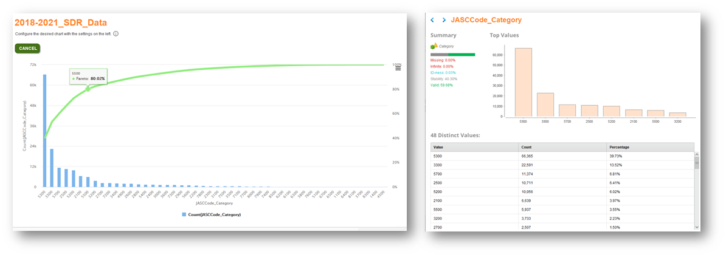

* The seven most common JASC Code Categories account for roughly ≈ 80% of all SDRs
  + - 5300 – Fuselage
    - 3300 – Lights
    - 5700 – Wings
    - 2500 – Equipment/Furnishing
    - 5200 – Doors
    - 2100 – Air Conditioning
    - 5500 – Stabilizers
* Thirty-seven different JASC Code Categories are used on less than 1% of SDRs and represent ≈ 10% of all SDRs.

In an attempt to compensate for this class imbalance, the SDR database was queried to return additional SDRs with the some of the least occurring JASC Code Category occurrences – although this search was restricted SDRs from 6/1/2000 and was limited to a 1,000-row maximum. It is worth noting that these additional SDRs included JASC Codes only at the chapter level and did not drill down into the four-digit JASC Codes. Working with a more exhaustive dataset population would likely only increase overall model efficacy and, therefore, may be considered with improved dataset accessibility.

## **Data Conditioning**

The data gathered from the FAA website was tab delimited in a Microsoft Excel format. Each record begins with a <td> and the fields are separated using <td> ending with </td> and the SDR record is separated with a <tr>. An example field in a record, Operator Control Number, appears as <td style='white-space:nowrap;text-align:left;'>UIEA2019020103084</td>. The field of interest (Discrepancy) was the last field in each record. At times Discrepancy includes additional markup language such as <P> and <DIV> which caused a separation in the rows when viewing the data in excel. The team used an HTML import to account for these additional markups or manually edited csv files in Excel.

Following generally accepted best practices and because the dataset acquisition process was conducted by multiple individuals including several iterations, the first step in the data conditioning process was to check for – and remove – any duplicate records. Data integrity and data quality is critical in any analysis project and duplicative information produces a misrepresentation of a sample space and can ultimately lead to misguided findings.

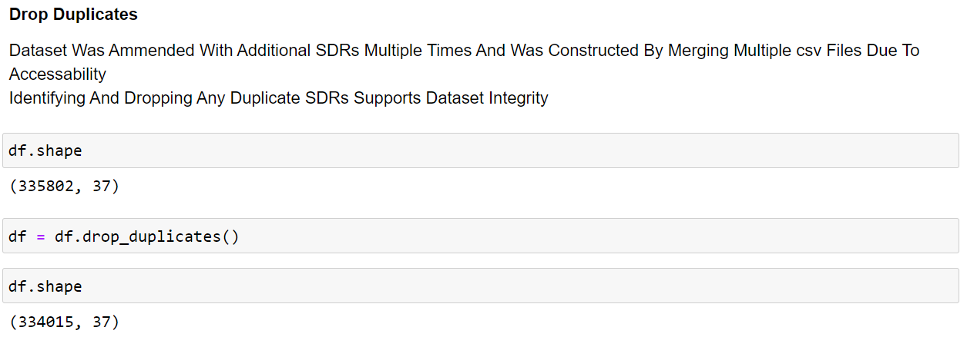

After ensuring no duplicate rows were present, several data conditioning steps were performed on the dataset depending on the attribute type. Most of the data across each field contains numerical or categorical data that follows a set structure thus requiring a more traditional, less exhaustive, conditioning process. The primary field of interest was the ‘discrepancy’ field which contains the descriptive narration of the SDR as it was filled out by the submitter and was relabeled as ‘text’. Fields other than the discrepancy field were concatenated and stored as a single field called ‘othertext’.

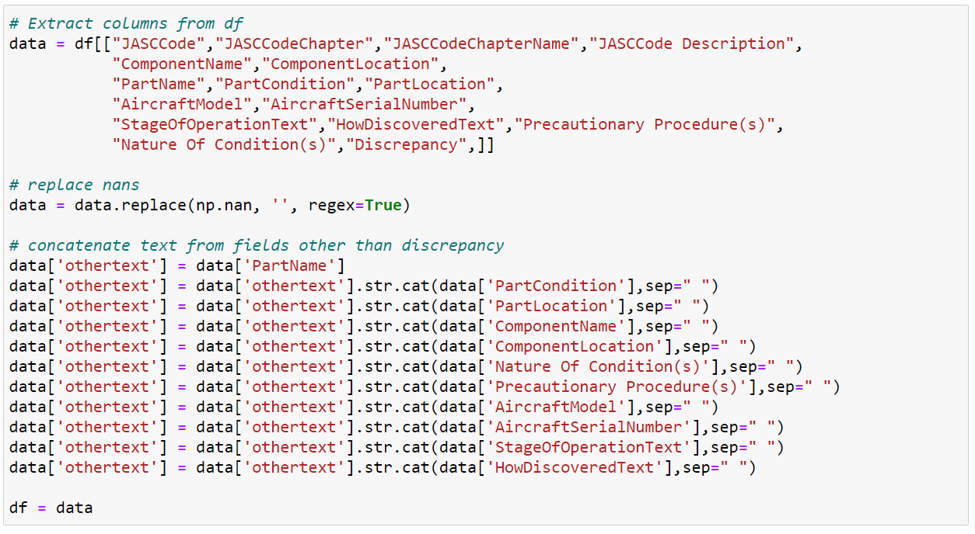

Where the ‘text’ field was more unstructured and rawer, the ‘othertext’ field followed a more structured format. Therefore, the text column required a more thorough cleansing than the ‘othertext’ column. To provide a baseline, an initial length calculation was performed on the ‘text’ column which indicated a length of nearly 65 million characters.

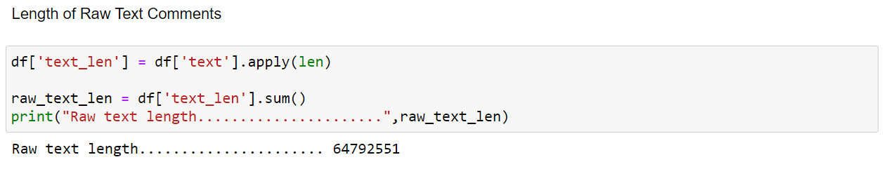

Upon viewing multiple examples of the discrepancy column, it was clear numerous industry specific acronyms and abbreviations were used. Exploring this further, the team created and applied a function on the text which removed all words not on the working list of common abbreviations and acronyms provided by the FAA client team. In addition, the team created word clouds for JASC Codes and JASC Code Chapters which provide an effective visual aid to explore text data and relationships between different classes of a target variable.

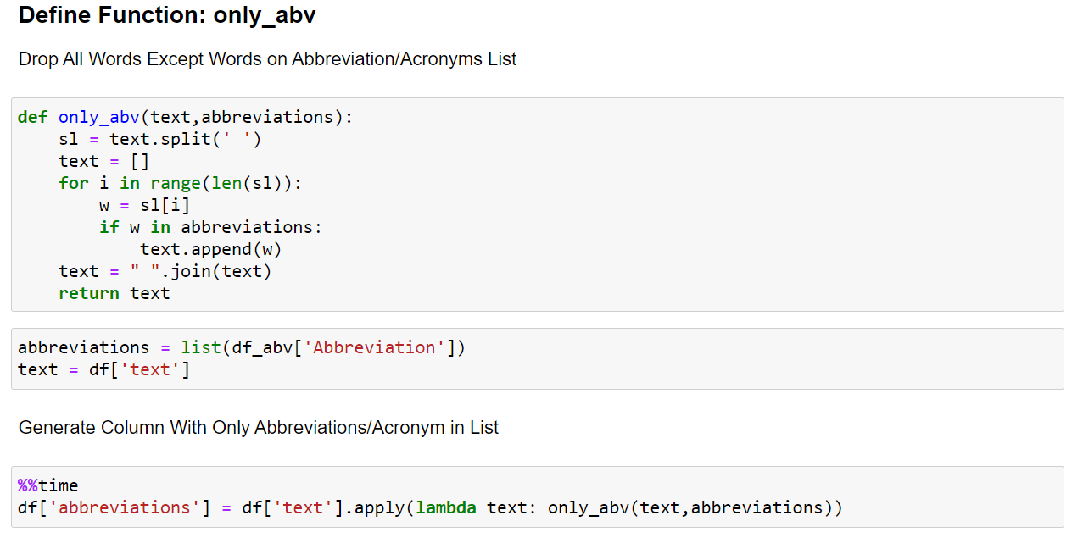

Several valuable insights were discovered after sharing this information with the client team. Some of the abbreviations on the list needed to be removed because they are commonly used words in the English language. Such as the key; value pair: AND; aircraft nose down – among others. Exploring the frequency of occurrences for other items on the list provided additional insight to their frequency of use, or lack thereof. Word clouds often provided clues to potential meanings of unknown strings of characters. A number of frequently occurring abbreviations were determined to references to specific repair manuals that are likely correlated to JASC Codes. These abbreviations were intentionally not substituted and were addressed separately. The final list of acronyms and abbreviations to be substituted included 747 items and made approximately 300,000 substitutions, effectively increasing the text length to nearly 70 million characters (≈7% increase). It is worth noting that this step was intentionally not performed on the ‘othertext’ field because of it more structured nature.

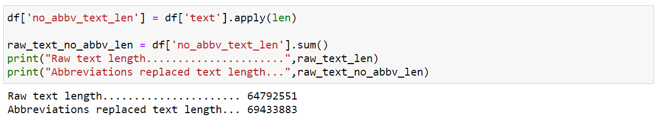

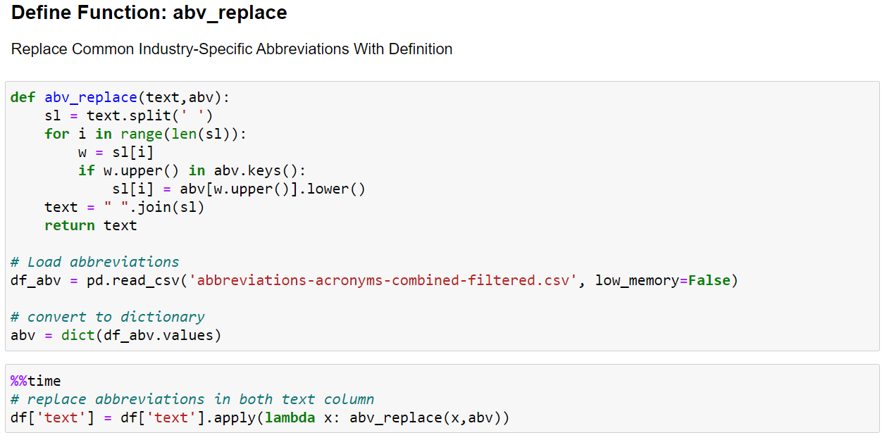

Viewing the frequency of occurrence for the abbreviations helps provide understanding as to how often some are used as well as how infrequent others may be used.

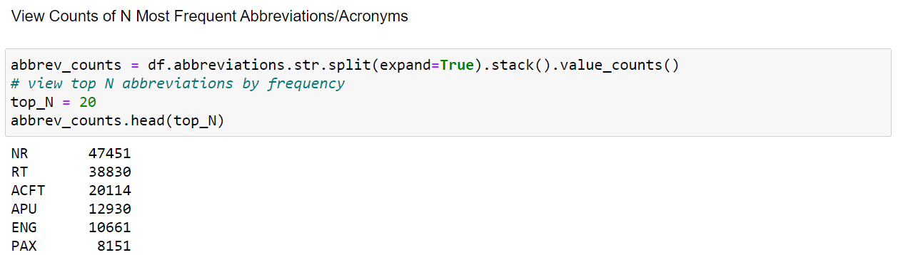

Some of the most common substituted abbreviations and acronyms included:

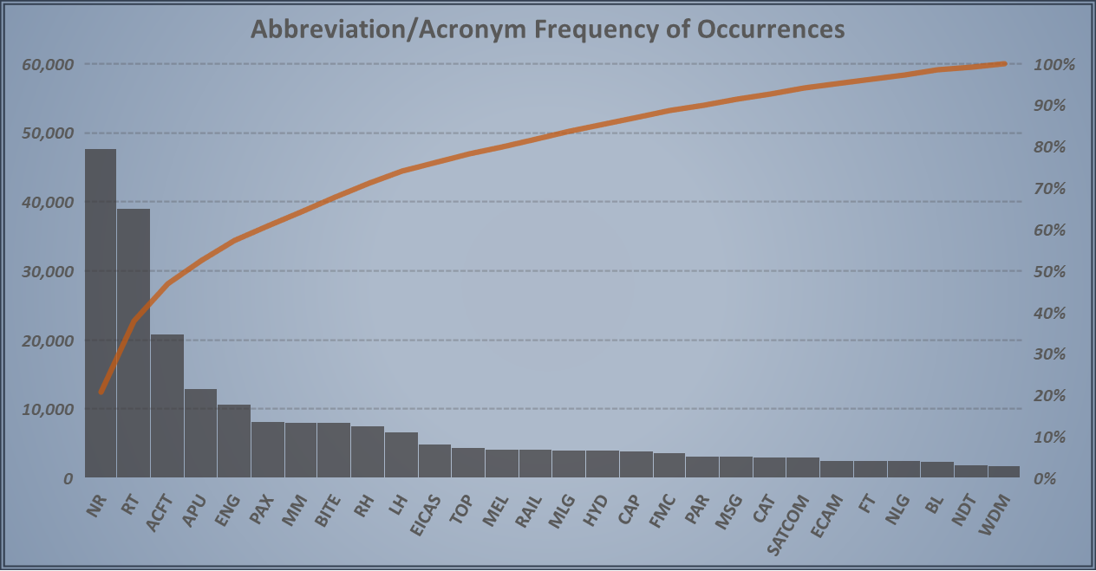

After replacing common abbreviations a first round of text cleansing was applied to both the ‘text’ and the ‘othertext’ fields. This first round of cleansing transformed all of the text to lower case and removed some punctuation. Some of the punctuation was left in place in order to preserve the structure of the previously defined list of abbreviation making a reference to specific repair manuals (among others).

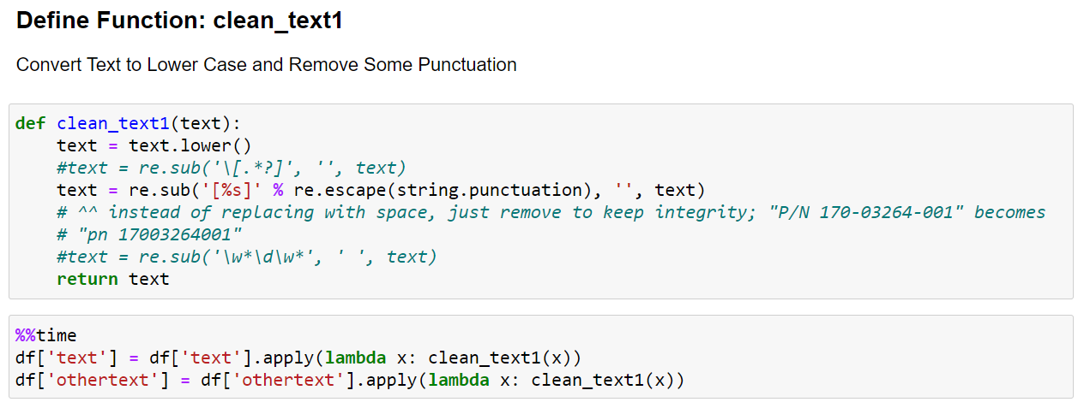

Next, functions were applied to the ‘text’ field to extract these references along with the first four numbers that followed immediately after the abbreviated reference. In addition, new columns were added that logged any time one of these references were present in any given SDR so that it could be explored further. The most common references made were SRM (Structure Repair Manual) and AMM (Aircraft Maintenance Manual). After extracting manual references, additional rounds of text cleansing were administered by applying functions that remove additional punctuation, any jumbled text, numbers (not attached to manual references), as well as any single characters or strings with a length greater than fourteen. After executing these steps, the ‘text’ field was relatively clean and trimmed down to an approximate total length of 61 million characters (≈12% decrease) which could be thought of as the volume of SDR vocabulary.

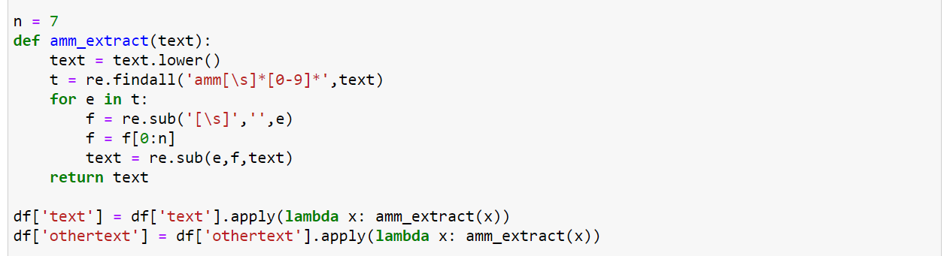

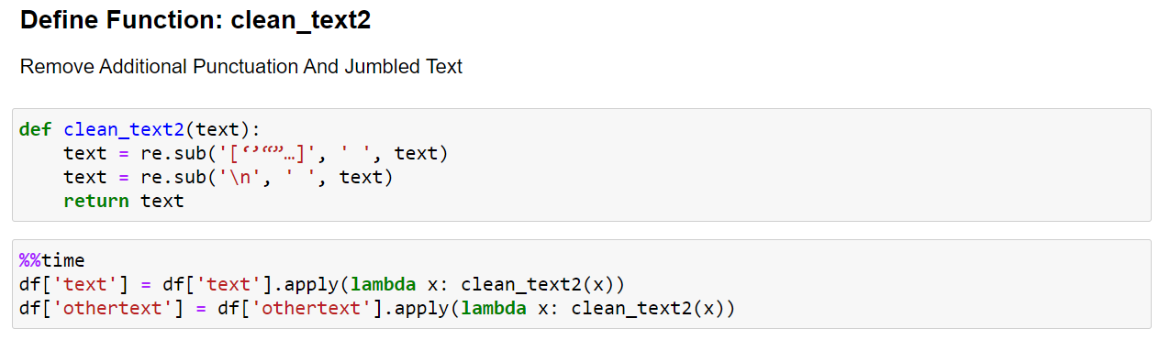

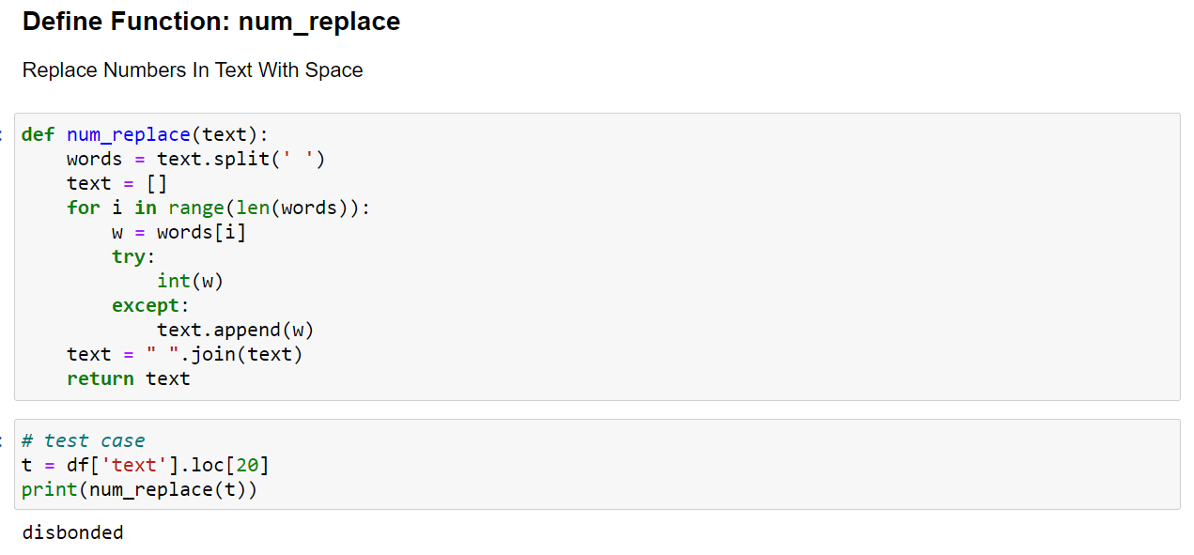

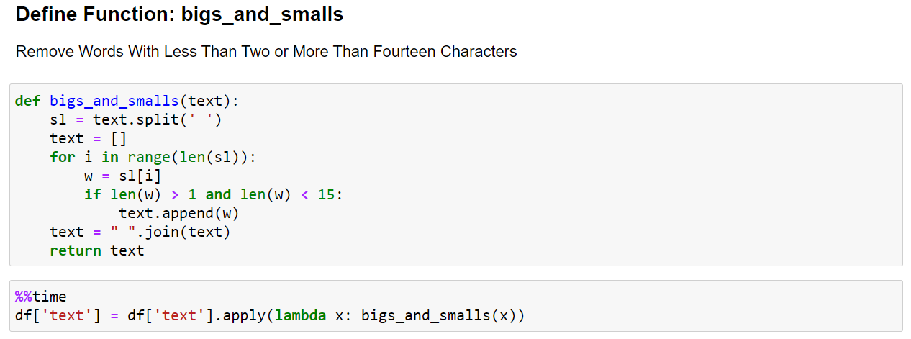

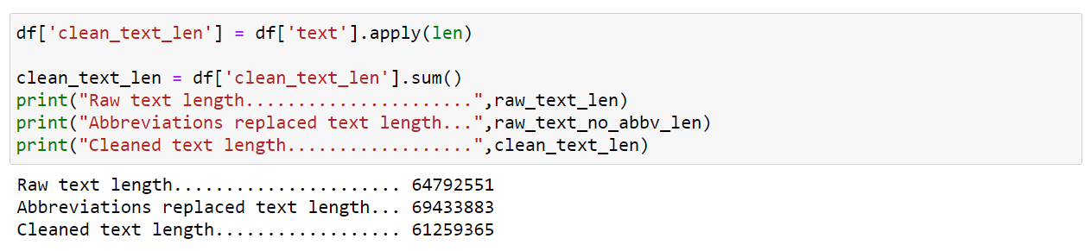

After cleaning the text data, one of the more common steps in text analysis projects is to remove stopwords. Stopwords are commonly used words (such as “the”, “a”, “and”, “in”) that occur often, provide little value to the context, and are generally considered safe to ignore. Therefore, stopwords were removed from the ‘text’ field as well as the ‘othertext’ field. Removing stopwords dramatically reduced the length of the ‘text’ column to 45 million characters (≈25% decrease).

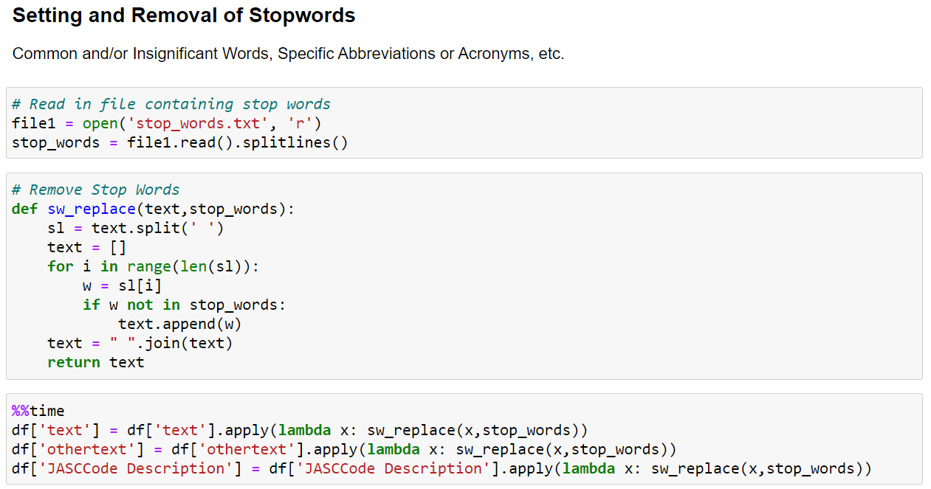

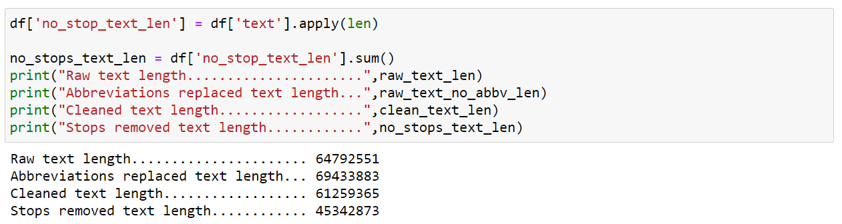

The final step in the data conditioning process utilized a function to lemmatize, or transform, words to their root word. Lemmatizing text data helps reduce the volume and variety of vocabulary by making slight variations of the same word appear the same within the data which reduces the number of unique features without losing the context or meaning within the text data. For example, ‘required’, ‘requires’, and ‘require’ can all safely be represented by ‘require’. Applying the lemmatization further reduced the length of the ‘text’ column to 43.5 million characters.

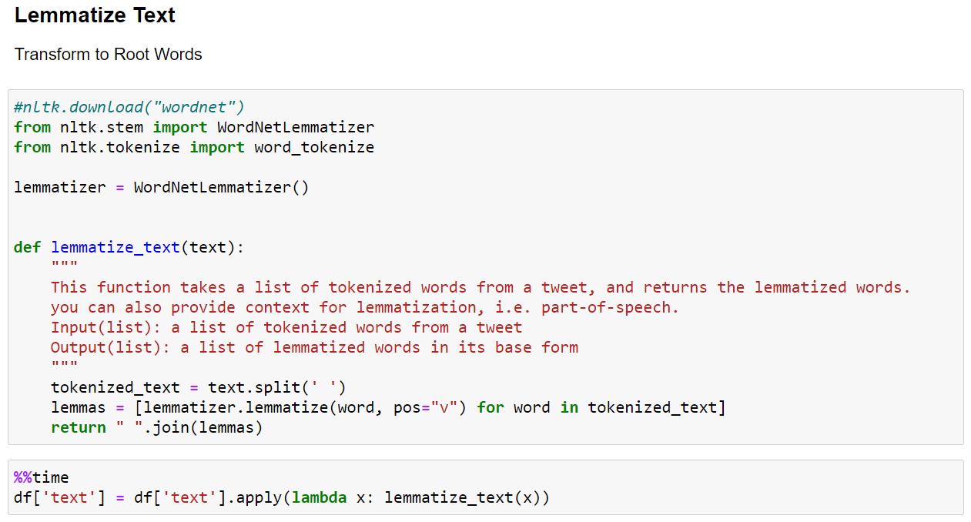

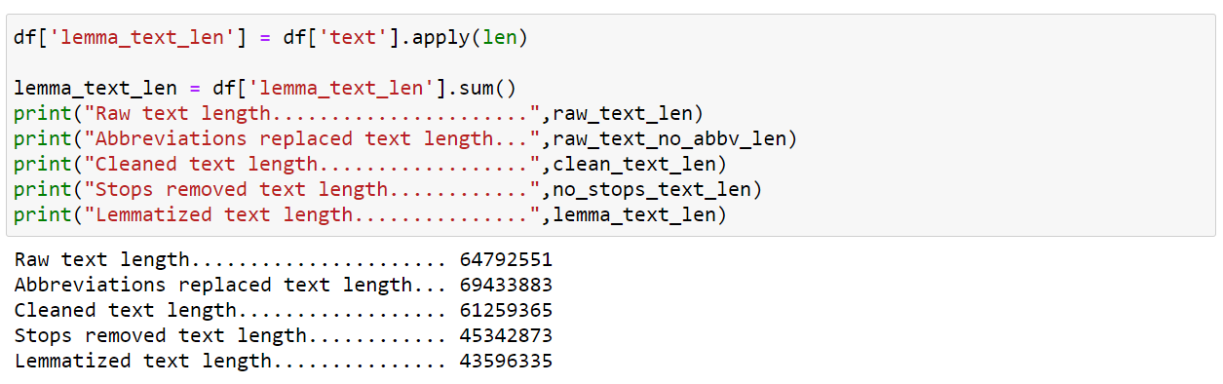

## **Data Quality Assessment**

Advances in technology, computing power, and data accessibility have contributed to Big Data surpassing oil as the most valuable resource in our economy. However, the inherent value of Big Data has its limitations. The age-old concept of “garbage in, garbage out” directly applies to both small, and big, data analysis projects. The performance of any given model is dependent upon the quality of the data used to construct the model – even for the most innovative and sophisticated models. To maximize the value of Big Data, the overall quality of the dataset is paramount. Therefore, conducting a complete and thorough assessment of the dataset is a critical step in any analysis project. The quality of the dataset was assessed on the following features:

| **Assessment Criteria** | **Scale** | **Description** |
| --- | --- | --- |
| **Completeness** | 0 - 100% | Requires that a particular column, element, or class of data is populated and does not feature null values or values in place of nulls (e.g., N/A). Completeness is an indication of comprehensiveness, measured as a percentage where 100% complete indicates all necessary records are present. When critical data is missing, the percentage of completeness is reduced. |
| **Consistency** | 0 - 100% | Something that tests weather one fact is consistent with another. A measure representing a percentage of data that reflect the same information as intended. Inconsistent data includes attributes or data not expected for intended information. |
| **Uniqueness** | 0 - 100% | Are all the entities or attributes within a dataset unique? A measure of duplicate values of items within a data set. Uniqueness = distinct values divided by count of values. |
| **Stability** | 0 - 100% | Count of most frequent non-missing value divided by total number of rows. |
| **Integrity** | 0 - 100% | Are all the relationships populated for a particular entity? [e.g., the inability to link related records together may introduce duplication across systems] |
| **Conformity** | 0 - 100% | Does the data conform to right conventions and standards? |
| **Validity** | 0 - 100% | Fraction of values which are not counted as missing, infinite, ID, or stable. |
| **Accuracy** | 0 - 100% | Refers to whether the data values stored for an object are the correct values. To be correct, a data values must be the right value and must be represented in a consistent and unambiguous form. For example, my birth date is December 13, 1941. |
| **ID-ness** | 0 - 100% | Fraction of values which are ID-like. |
| **Timeliness** | 0 - 100% | Degree to which the data is up-to-date and available within acceptable time frame, timeline, and duration. |
| **Overall Quality** | 0 - 100% | Overall grade based on all other assessment categories |
| *Sources: [bmc.com/blogs/data-integrity-vs-data-quality/#] [DAEN 690 Presentation Template] [Rapid Miner]* | | |

A complete data quality assessment determined the dataset to be within the expected range of similar industries. Fields throughout the dataset are known to vary between different carriers. Some have a better track record of providing complete and accurate reports, while others less so. Numerous fields include a large percentage of empty values, although many of these may be expected because every field is not a required by the FAA and some fields by not be applicable to all JASC codes. Gaining a thorough understanding of the process in which SDRs are filled out may provide some insight to unseen patterns and structure. Other inconsistencies worth noting include characters present in fields of measurements (mostly in columns 56 – 71) and the length of the discrepancy being more than the stated rule of 1,500 characters.

Illustrated below is the complete data quality assessment:

| Attribute | Complete-ness | Unique-ness | ID-ness | Stability | Validity | Consistency | Accuracy | Conformity | Timeliness |
| --- | --- | --- | --- | --- | --- | --- | --- | --- | --- |
| OperatorControlNumber | **100%** | **99%** | **3%** | **0%** | **97%** | **90%** | **95%** | **95%** |  |
| DifficultyDate | **100%** | **100%** | **0%** | **0%** | **100%** | **100%** | **100%** | **100%** | **100%** |
| SubmissionDate | **100%** | **100%** | **0%** | **0%** | **100%** | **100%** | **100%** | **100%** | **100%** |
| OperatorDesignator | **97%** | **0%** | **0%** | **16%** | **82%** | **100%** | **100%** | **100%** |  |
| SubmitterDesignator | **98%** | **0%** | **0%** | **16%** | **82%** | **100%** | **100%** | **100%** |  |
| SubmitterTypeCode | **100%** | **0%** | **0%** | **93%** | **7%** | **100%** | **100%** | **100%** |  |
| ReceivingRegionCode | **100%** | **0%** | **0%** | **40%** | **60%** | **100%** | **100%** | **100%** |  |
| ReceivingDistrictOffice | **100%** | **100%** | **0%** | **17%** | **83%** | **100%** | **100%** | **100%** |  |
| SDRType | **100%** | **0%** | **0%** | **97%** | **3%** | **100%** | **100%** | **100%** |  |
| JASCCode | **100%** | **0%** | **0%** | **15%** | **85%** | **100%** | **100%** | **100%** |  |
| NatureOfConditionA | **100%** | **0%** | **0%** | **77%** | **23%** | **100%** | **100%** | **100%** |  |
| NatureOfConditionB | **2%** | **1%** | **0%** | **56%** | **0%** | **100%** | **100%** | **100%** |  |
| NatureOfConditionC | **0%** | **11%** | **0%** | **17%** | **0%** | **100%** | **100%** | **100%** |  |
| PrecautionaryProcedureA | **100%** | **0%** | **0%** | **80%** | **20%** | **100%** | **100%** | **100%** |  |
| PrecautionaryProcedureB | **1%** | **1%** | **0%** | **62%** | **0%** | **100%** | **100%** | **100%** |  |
| PrecautionaryProcedureC | **0%** | **9%** | **0%** | **25%** | **0%** | **100%** | **100%** | **100%** |  |
| PrecautionaryProcedureD | **0%** | **15%** | **0%** | **33%** | **0%** | **100%** | **100%** | **100%** |  |
| StageOfOperationCode | **100%** | **0%** | **0%** | **74%** | **26%** | **100%** | **100%** | **100%** |  |
| HowDiscoveredCode | **100%** | **0%** | **0%** | **44%** | **56%** | **100%** | **100%** | **100%** |  |
| RegistryNNumber | **98%** | **7%** | **2%** | **0%** | **96%** | **90%** | **100%** | **100%** |  |
| AircraftMake | **89%** | **0%** | **0%** | **46%** | **54%** | **90%** | **95%** | **90%** |  |
| AircraftModel | **100%** | **1%** | **0%** | **10%** | **90%** | **60%** | **70%** | **90%** |  |
| AircraftSerialNumber | **98%** | **7%** | **2%** | **0%** | **96%** | **70%** | **85%** | **100%** |  |
| AircraftTotalTime | **98%** | **100%** | **2%** | **0%** | **96%** | **100%** | **100%** | **100%** |  |
| AircraftTotalCycles | **97%** | **100%** | **2%** | **0%** | **95%** | **100%** | **100%** | **100%** |  |
| EngineMake | **4%** | **0%** | **0%** | **26%** | **0%** | **100%** | **100%** | **100%** |  |
| EngineModel | **4%** | **8%** | **0%** | **7%** | **0%** | **100%** | **100%** | **100%** |  |
| EngineSerialNumber | **1%** | **82%** | **0%** | **4%** | **0%** | **100%** | **100%** | **100%** |  |
| EngineTotalTime | **1%** | **100%** | **0%** | **4%** | **0%** | **100%** | **100%** | **100%** |  |
| EngineTotalCycles | **1%** | **100%** | **0%** | **7%** | **0%** | **100%** | **100%** | **100%** |  |
| PropellerMake | **0%** | **1%** | **0%** | **60%** | **0%** | **100%** | **100%** | **100%** |  |
| PropellerModel | **0%** | **25%** | **0%** | **20%** | **0%** | **100%** | **100%** | **100%** |  |
| PropellerSerialNumber | **0%** | **91%** | **0%** | **13%** | **0%** | **100%** | **100%** | **100%** |  |
| PropellerTotalTime | **0%** | **100%** | **0%** | **13%** | **0%** | **100%** | **100%** | **100%** |  |
| PropellerTotalCycles | **0%** | **99%** | **0%** | **100%** | **0%** | **100%** | **100%** | **100%** |  |
| PartMake | **34%** | **1%** | **0%** | **31%** | **3%** | **100%** | **100%** | **100%** |  |
| PartName | **100%** | **1%** | **0%** | **6%** | **94%** | **100%** | **100%** | **100%** |  |
| PartNumber | **52%** | **32%** | **1%** | **2%** | **49%** | **100%** | **100%** | **100%** |  |
| PartSerialNumber | **10%** | **82%** | **0%** | **2%** | **8%** | **100%** | **100%** | **100%** |  |
| PartCondition | **100%** | **0%** | **0%** | **25%** | **75%** | **100%** | **100%** | **100%** |  |
| PartLocation | **98%** | **7%** | **1%** | **16%** | **82%** | **100%** | **100%** | **100%** |  |
| PartTotalTime | **8%** | **100%** | **0%** | **1%** | **7%** | **100%** | **100%** | **100%** |  |
| PartTotalCycles | **7%** | **100%** | **0%** | **1%** | **5%** | **100%** | **100%** | **100%** |  |
| PartTimeSince | **5%** | **100%** | **0%** | **6%** | **0%** | **100%** | **100%** | **100%** |  |
| PartSinceCode | **6%** | **0%** | **0%** | **41%** | **0%** | **100%** | **100%** | **100%** |  |
| ComponentMake | **1%** | **9%** | **0%** | **15%** | **0%** | **100%** | **100%** | **100%** |  |
| ComponentModel | **0%** | **59%** | **0%** | **25%** | **0%** | **100%** | **100%** | **100%** |  |
| ComponentName | **1%** | **26%** | **0%** | **6%** | **0%** | **100%** | **100%** | **100%** |  |
| ComponentPartNumber | **1%** | **56%** | **0%** | **6%** | **0%** | **100%** | **100%** | **100%** |  |
| ComponentSerialNumber | **1%** | **66%** | **0%** | **5%** | **0%** | **100%** | **100%** | **100%** |  |
| ComponentLocation | **1%** | **15%** | **0%** | **13%** | **0%** | **100%** | **100%** | **100%** |  |
| ComponentTotalTime | **0%** | **100%** | **0%** | **5%** | **0%** | **100%** | **100%** | **100%** |  |
| ComponentTotalCycles | **0%** | **100%** | **0%** | **7%** | **0%** | **100%** | **100%** | **100%** |  |
| ComponentTimeSince | **0%** | **100%** | **0%** | **25%** | **0%** | **100%** | **100%** | **100%** |  |
| ComponentSinceCode | **1%** | **1%** | **0%** | **55%** | **0%** | **100%** | **100%** | **100%** |  |
| FuselageStationFrom | **22%** | **100%** | **0%** | **4%** | **18%** | **70%** | **60%** | **75%** |  |
| FuselageStationTo | **9%** | **100%** | **0%** | **4%** | **5%** | **70%** | **60%** | **75%** |  |
| StringerFrom | **10%** | **100%** | **0%** | **12%** | **0%** | **70%** | **60%** | **75%** |  |
| StringerFromSide | **10%** | **0%** | **0%** | **53%** | **0%** | **95%** | **95%** | **95%** |  |
| StringerTo | **4%** | **100%** | **0%** | **9%** | **0%** | **70%** | **60%** | **75%** |  |
| StringerToSide | **5%** | **0%** | **0%** | **63%** | **0%** | **100%** | **100%** | **100%** |  |
| WingStationFrom | **2%** | **100%** | **0%** | **11%** | **0%** | **70%** | **60%** | **75%** |  |
| WingStationFromSide | **2%** | **0%** | **0%** | **51%** | **0%** | **100%** | **100%** | **100%** |  |
| WingStationTo | **1%** | **100%** | **0%** | **10%** | **0%** | **70%** | **60%** | **75%** |  |
| WingStationToSide | **1%** | **0%** | **0%** | **59%** | **0%** | **100%** | **100%** | **100%** |  |
| ButtLineFrom | **13%** | **100%** | **0%** | **9%** | **4%** | **70%** | **60%** | **75%** |  |
| ButtLineFromSide | **14%** | **0%** | **0%** | **50%** | **0%** | **100%** | **100%** | **100%** |  |
| ButtlineTo | **2%** | **100%** | **0%** | **7%** | **0%** | **70%** | **60%** | **75%** |  |
| ButtlineToSide | **5%** | **0%** | **0%** | **52%** | **0%** | **100%** | **100%** | **100%** |  |
| WaterLineFrom | **3%** | **100%** | **0%** | **17%** | **0%** | **70%** | **60%** | **75%** |  |
| WaterLineTo | **0%** | **100%** | **0%** | **8%** | **0%** | **70%** | **60%** | **75%** |  |
| CrackLength | **2%** | **100%** | **0%** | **35%** | **0%** | **70%** | **60%** | **75%** |  |
| NumberOfCracks | **4%** | **100%** | **0%** | **89%** | **0%** | **100%** | **100%** | **100%** |  |
| CorrosionLevel | **11%** | **100%** | **0%** | **98%** | **0%** | **100%** | **100%** | **100%** |  |
| StructuralOther | **5%** | **24%** | **0%** | **2%** | **4%** | **40%** | **30%** | **90%** |  |
| Discrepancy | **100%** | **100%** | **3%** | **0%** | **97%** | **100%** | **100%** | **100%** |  |

## **Other Data Sources**

Using other sources such as ATA codes and specifications was considered. However, the FAA team provided guidance that indicated these codes were more useful to aircraft manufacturers and may ultimately introduce unnecessary complexity and confusion surrounding model interpretation. The JASC codes were coordinated with Canada and Australia and are useful across the industry – especially at the chapter (two-digit) level. Several supplementary documents were either provided by the FAA client team or sourced from the SDR website on the line which include a JASC Code Dictionary, PartName and PartCondition tables, NatureOfCondition table, PrecautionaryMeasure table, StageOfOperation table, as well as the working list of common abbreviations with known definitions. Many of these tables were used to transform codes to their textual definitions in an attempt to provide more insight into the interpretations of certain fields – especially to individuals without industry experience and/or knowledge. The JASC Code Dictionary was considered as a potential candidate for determining weights to place on certain features intending to draw clear boundaries between commonly misclassified JASC Codes.

# **Analytics and Algorithms**

## **Tokenization and Vectorization**

In natural language processing tasks, the words used in all the text observations form the basis for the features. The process of extracting words from the text is the tokenization. The team was able to use a space in the text as a separator. Once the words are tokenized then each word becomes a feature or column in a matrix where each row is the actual text with a record or cell in the matrix represents the presence or absence of a word. Other techniques may represent the count of a word or the frequency of a word relative to all the other text. This process is the vectorization which transforms the tokens into vectors.

In this project, each word is taken from several fields in a Service Deficiency Report. This creates a sparse matrix where many dimensions are False or 0 while a few are True or some positive value. Further exacerbating the challenge are combinations of words called N-grams, where the ‘N’ represents the number of words, or tokens, taken together as a single token. This expands a vocabulary of several hundred thousand in length into well over a million. Keep in mind, there were approximately 350,000 SDRs were created in the last 5 years.

## **Count Vectorizer**

Text transformation beyond the absence or presence of a token in a document is to count the occurrences of terms in each document. The count vectorizer in SKlearn iterates through all the documents creating a column for each word or Ngram and then in each row places an integer count. There are parameters for limiting the number of words and for the length of Ngrams. The team explored various counts and Ngrams as a precursor to feature selection algorithms.

## **Feature Selection**

The ability to filter features that are noisy, don’t change, or don’t correlate with the JASC classification will dramatically reduce the processing power and memory required for classification tasks. The first method is to filter a feature in the training set that has a variance lower than a given threshold. The higher the threshold, the more features that are used until the default – which only filters features that have the same value across all observations. This method is called the Variance Threshold from SKlearn and is illustrated in the following code snippet:

**# X% threshold for the feature to be on or off in samples**

threshold = 0.99

from sklearn.feature_selection import VarianceThreshold

sel = VarianceThreshold(threshold=(threshold * (1 - threshold)))

sel.fit_transform(x_train)

**# Create Vocabulary**

sel_list = [ i for i, f in enumerate(sel.get_support()) if f ]

x_names = []

for item in sel_list:

print(vectorizer.get_feature_names()[item])

x_names.append(vectorizer.get_feature_names()[item])

**# now use the limited list of features**

vectorizer = feature_extraction.text.TfidfVectorizer(vocabulary=x_names)

vectorizer.fit(corpus)

x_train = vectorizer.transform(corpus)

dic_vocabulary = vectorizer.vocabulary_

Another feature selection method looks at the univariate comparison between the feature and the class. The Chi Square test failed to reduce the number of features at the 95% threshold in any significant manner, 20,000 features to 19,992. The following code snippet was used to identify by class the words or Ngrams that are at least 95% independent.

**# df_features is a blank dataframe**

df_features = pd.DataFrame()

**# for each unique JASC code check if the feature and JASC code are independent**

for cat in np.unique(y):

**# compute chi-squared and get the p-value**

chi2, p = feature_selection.chi2(x_train_other, y==cat)

**# get the feature names**

df_features = df_features.append(pd.DataFrame(

{"feature":x_names_other,"score":1-p,y":cat}))

**# sort by score**

df_features = df_features.sort_values(["y","score"],

ascending=[True,False])

**# keep if over the p value**

df_features = df_features[df_features["score"]>p_value_limit]

x_names_other = df_features["feature"].unique().tolist()

## **Feature Reduction**

Another technique the team considered is selecting a limited amount of text from each Service Deficiency Report. Some of the fields are free-text response from the technician. Other fields are selected from a list by the technician. Furthermore, some of the fields are mandatory while others are optional. The mandatory fields were recommended by the FAA since changes to the Service Deficiency Report format could be made to the optional fields, especially infrequently used fields could be dropped.

The focus is on the Discrepancy field and using that text to identify the class. The other mandatory fields that are selected by the technician were also considered. Furthermore, a combination of all the fields was compared.

## **Term Frequency – Inverse Document Frequency**

Data preparation was done using Term Frequency – Inverse Document Frequency (TF-IDF) to form vectors for all the terms in the discrepancy field. Other fields such as part names, part location, and component location were merged with the vectorized discrepancy field to add weight to certain terms which were submitted by technicians. A TF-IDF is one method used to measure how relevant a word is to a given document.

The first step to calculate a TF-IDF is to calculate the TF (Term Frequency) which represents how frequent a word appears in a document:

***TF (word, d#) = # of times word occurs / total number of words***

The second step is to calculate the IDF (Inverse Documents Frequency):

***IDF (word, C) = log (# of documents in corpus / # of documents word occurs in)***

The IDF is a constant for the entire corpus and represents the ratio of documents that include that specific word. The TF-IDF value, calculated by multiplying the TF and IDF, then increases proportionally to the frequency at which a word appears within that given document and is offset by the number of documents in the corpus that contain the word. This, in effect, accounts for words that naturally appear more frequently in general context and weights the terms individually.

For example, consider a corpus of two JASC Code Chapters and their descriptions:

Corpus C

|  |  |  |  |
| --- | --- | --- | --- |
| d1 | 5600 | Windows | pilot cockpit window crack. captain window damage. repair windshield crack. rear sliding window repair. |
| d2 | 5700 | Wing Structure | **repair** rib skin. left hand wing. wing skin corrosion **repair**. **repair** crack rib skin. corrosion **repair** on rh wing structure. |

The word repair has a larger term frequency in JASC Chapter 5700: Wing Structure

* TF (“**repair**”, d1) = 2/14 ≈ 0.14
* TF (“**repair**”, d2) = 4/20 ≈ 0.20

The word repair occurs in every document in the corpus

* IDF (“**repair**”, C) = log (2/2) = 0

The word window has a larger term frequency in JASC Chapter 5600: Windows

* TF-IDF (“**repair**”, d1, C) = 0.14 × 0 = 0
* TF-IDF (“**repair**”, d2, C) = 0.20 × 0 = 0
* TF (“**window**”, d1) = 3/14 ≈ 0.21
* TF (“**window**”, d2) = 0/20 ≈ 0.00

The word window occurs in only one of the two documents in the corpus

* IDF (“**window**”, C) = log (2/1) = log (2) ≈ 0.30
* TF-IDF (“**window**”, d1, C) = 0.21 × 0.30 = 0.063
* TF-IDF (“**window**”, d2, C) = 0.00 × 0.30 = 0.000

The word window is more relevant to the JASC Chapter 5600: Windows than it is relevant to the JASC Chapter 5700: Wing Structure.

Performing these calculations across all features produces a complete TF-IDF. Analysis of the TF-IDF can help reveal insight in which words are most relevant to the different documents in the corpus and which key words distinguish differences between the different documents.

## **Class Imbalance**

Imbalance in the dataset among the classes may lead to inaccuracy of the classifier. As noted in the data analysis section several classes in the SDR dataset dominated the results. The top 7 Chapters and the top 49 Codes account for the top 80% of SDRs. The number of classes also makes prediction challenging. There are a total of 51 JASC Chapters where 3 are missing for a total of 48 classes at the Chapter level. There are well over 500 different classes at the code level. The team considered two approaches to handling the imbalance. One is grouping less frequently observed classes into a larger class. The other is to provide a means to find a signal word or Ngram that could be weighted and signal the class.

The groping of Chapters at the top 9 to provide over 80% of all the observations was first considered. The goal is to increase accuracy by focusing on a smaller set of classes and pool all the other less frequent classes into a group for manual inspection. Ultimately this would decrease the level of manual effort by 80% if the narrow class range was highly accurate. The trade-off for higher accuracy is that the machine learning algorithm would group words and Ngrams from all the less frequent groups and may lose the signal in those smaller groups. For example, part numbers specific to an infrequently used class may be drowned out by all the classes. Another trade-off of using a manual classification group is combining signals from a wide range of groups may create fuzzy boundaries that overlap with the top 9 Chapters. In other words, by grouping all the less frequent classes together the possibility for overlap with the top 9 dominant classes increases.

Similar analysis was done for the top 49 codes. In this case the accuracy always decreased as the number of Codes increased. Less frequent groups that are observed in the order of hundreds compared to tens of thousands for the frequent groups fail to pull through a signal the machine learning algorithm can detect. This even occurred as the Ngrams increased in range and a vocabulary of over 6 million Ngrams were used.

The FAA provided guidance around the value of accuracy and grouping less frequent classes for manual effort. The value in determining the JASC Chapter with a slightly lower overall accuracy was considered a major improvement. This 2-digit Chapter will help the FAA in pinpointing the section, 4-digit code. The accurate classification down to the 4-digit code using the top 80% will significantly help the FAA reduce the manual effort. Thus, accounting for the imbalance in the Chapters is less valuable to the FAA and prediction at the full Chapter is preferred. On the other hand, predicting the top 49 Codes will greatly reduce the manual effort and the 2-digit point will provide a means to further reduce the manual effort.

## **Precision and Recall**

The accuracy of a classifier has several different measurements beyond the percent correctly classified. The precision measures the proportion of positive identifications that were actually correct. If the model has no false positives then the precision is 1 or 100%. The recall is the measure of the proportion of actual positives that were identified correctly. If the model has no false negatives then the recall is 1 or 100%. In the case of the JASC Chapter and Code classification is positive if the label predicted is the correct class and negative if it is the wrong class.

There is a balance between false positives and false negatives for classifiers. In the example of a catch-all class that accounts for the infrequently observed JASC codes, increasing the number of false positives means adding to the manual effort of the FAA. On the contrary, under classifying the catch-all class would falsely assign a JASC Code and lead to inaccurate assessment of the frequency of the top 49 JASC Codes.

In consultation with the FAA, there was no defined guidance on the value of a false positive or negative. In some cases, a false positive may mean predicting a fault is occurring much more frequently than reality leading to policy for the industry that causes a misallocation of resources for aircraft operators. The desire of the FAA is for explainability, in terms of percentage of certainty the model assesses for its prediction. This will allow the FAA to adopt the model and over time assess the value of false positives to false negatives and include that calculation into further model tuning.

## **Naïve Bayes Multinomial Algorithm**

Naive Bayes multidimensional algorithm is an algorithm that is rapid to execute and provide a baseline for more sophisticated learning algorithms. Bayes Theorem of conditional probability allows for a simplification of conditional probability when events are considered independent. In terms of this project the probability of a JASC code given a term is used.

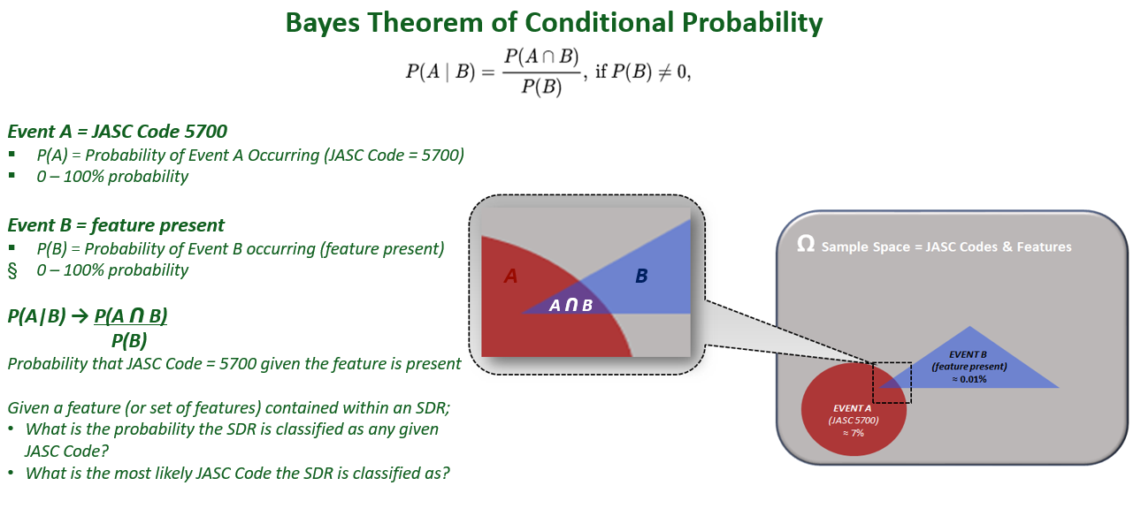

## **K-Nearest Neighbors**

This algorithm uses distance between different features in order to form groups. The K-NN algorithm can be used to classify both continuous and discrete variables. A common distance metric for continuous variables is the Euclidean distance while for discrete variables (like text classification) other metrics can be used – such as the overlap metric. The classification accuracy of K-NN methods is sensitive to the distance metric so learning which metric is most suitable for the problem at hand is critical. Similarly, K-NN accuracy is dependent on the *k* parameter. Choosing an appropriate *k* parameter depends on the data. Smaller values of *k* reduce the effect of noise on the classification while larger values of *k* make for ambiguous boundaries between classes. Data exhibiting an unbalanced distribution of classes can be problematic because the more frequent classes will dominate the predictions as they will commonly be among their nearest neighbor(s).

The K-nearest neighbors using a defined number of classes. This was considered to provide a view of the most used JASC Chapters and determine a baseline for an algorithm which will automatically select a JASC code and other codes which should be manually assigned given these JASC chapters and codes are not frequently assigned. The accuracy, precision, and recall of the top JASC Chapters is shown below.

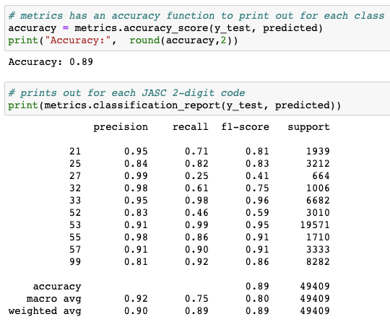

The recall of Chapter 52 is particularly concerning. Many cases of this Chapter are assigned to the incorrect class. Overall the KNN has a fairly high accuracy and balanced precision and recall.

The KNN was also recomputed with all the JASC Chapters. The K-NN algorithm was run again for all the JASC Chapters. The confusion matrix shows a fair amount of inaccuracy across each class although a predominance of the labels along the diagonal are correct.

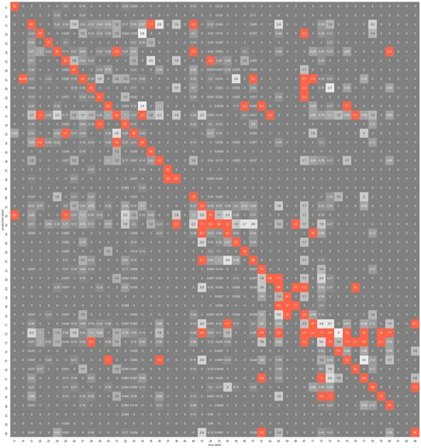

KNN is more frequently used in unsupervised learning where the KNN algorithm discovers classes hidden in an unlabeled dataset. In this case the labels were already assigned and the KNN was used to learn the patters from the data in order to predict the class of yet unseen data. The interesting point for the FAA is the use of an algorithm which shows how closely comparable some JASC Chapters are to each other. The terms are not wide and unique across the Chapters which would result in a pure alignment along the diagonal. Instead several Chapters are assigned the wrong labels.

## **Decision Tree Classifier**

Decision Trees are a common method used to predict a class or value of a target variable and is accomplished by learning simple decision rules inferred from prior data or training data. Decision Trees work by comparing attributes of the root with a record’s attributes and then this process is duplicated along different branches, or nodes, depending on the comparison traits.

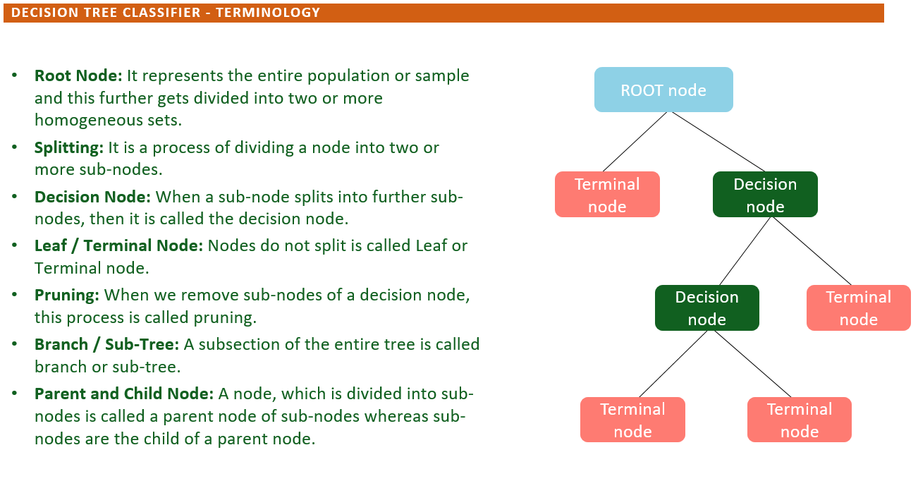

The Decision Tree Classifier was used to determine splits on a feature or features to minimize the amount of randomness at each step. This algorithm finds which features that mostly likely lead to a branch of JASC chapters (2-digit) or codes (4-digit). This serves as an easy to explain algorithm which is conducive to focus on data preparation such as lemmatization and a consistent use of abbreviations and expansions. The outcome was 90% on the JASC Chapter for accuracy. The confusion matrix shows a handful of JASC chapters which are difficult to identify such as Chapter 14 and 83.

Additional tuning for the decision tree was performed in terms of the depth of the tree and criterion. This analysis was done using a grid search to compare the gini and entropy criterion. The gini criterion produced the higher accuracy.

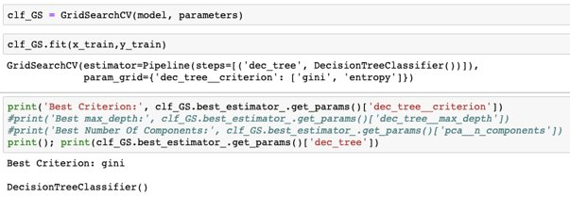

The depth of the tree had to be sufficiently large to improve accuracy. The overall computation time was well within a couple of minutes.

**|--- emergency <= 0.11**

**| |--- seat <= 0.25**

**| | |--- corrode <= 0.04**

**| | | |--- floor <= 0.25**

**| | | | |--- fuselage <= 0.02**

**| | | | | |--- door <= 0.09**

**| | | | | | |--- bs <= 0.01**

**| | | | | | | |--- flashlight <= 0.17**

**| | | | | | | | |--- pack <= 0.13**

**| | | | | | | | | |--- flap <= 0.26**

**| | | | | | | | | | |--- satcom <= 0.33**

**| | | | | | | | | | | |--- truncated branch of depth 314**

**| | | | | | | | | | |--- satcom > 0.33**

Further tuning such as adjusting abbreviations or combining JASC chapters and codes into a manual review label may prove beneficial.

## **Support Vector Machine**

This algorithm is a supervised learning algorithm using the n-dimensions of the data and forms a hyper-plane to split into the classes. The hyper-plane typically has one less dimension than the original data. For example, two-dimensional data is split by a one-dimension line, three-dimensional data by a two dimensional plane and so on. The Support Vectors form a margin between the classes in order to minimize error. In the SVM algorithm, we are looking to maximize the margin between the data points and the hyperplane. The loss function that helps maximize the margin is hinge loss.[6]

The SVM may use a linear classifier or a non-linear classifier. The linear classifier fits a linear hyperplane to split the data into classes. This is effective and the faster of the methods used by SVMs. The non-linear may find patterns in the data which are difficult to fit using a linear method. For example, data points of one class are nearest to the origin while data are outside of the bulls-eye around the origin. The following picture has a simplified view of the difference.

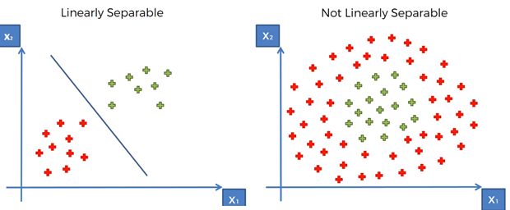

Image: <https://www.google.com/url?sa=i&url=https%3A%2F%2Fmedium.com%2Fpursuitnotes%2Fday-12-kernel-svm-non-linear-svm-5fdefe77836c&psig=AOvVaw1X0iZiVyWjJFsnWbLzy7mT&ust=1627925331541000&source=images&cd=vfe&ved=0CAsQjRxqFwoTCOCMgcyskPICFQAAAAAdAAAAABAD>

There are several options when using a Support Vector Machine. The first option considered is using a linear or non-linear Support Vector Classifier. The linear classifier was chosen due to computational time since the non-linear classifier failed to complete on the AWS SageMaker instance. Another parameter of the linear classifier are the number of iterations computed for each class. By default the LinearSVC uses 1,000 iterations for each class. An examination of the number of iterations used showed well less than 1,000.

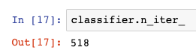

The type of multi-class algorithm was also explored. The crammer_singer while it reduces the options in several parameters such as mitigates the need to select loss and penalty functions was significantly longer in computation without any appreciable benefit in accuracy. This would result in using an option that reduces explanability of the model and increases computation time. Another parameter, class weight, was examined. The options for the class weight parameter are balanced or all classes with equal weight. There is an option to assign class weights with a disctionary but this was not explored. The balanced option of the class weight parameter accounts for infrequent classes by calculating a proportion of classes while the default option considers all classes of equal weight. There was no change in accuracy using the balanced and default option.

The positive from the Support Vector Machine, LinearSVC, is the ability to signal which words create the highest importance towards the classification. The LinearSVC object has a coef_ class that can be mined for the top 10 most important and top 10 least important. An example output was derived for the 2500 Chapter.

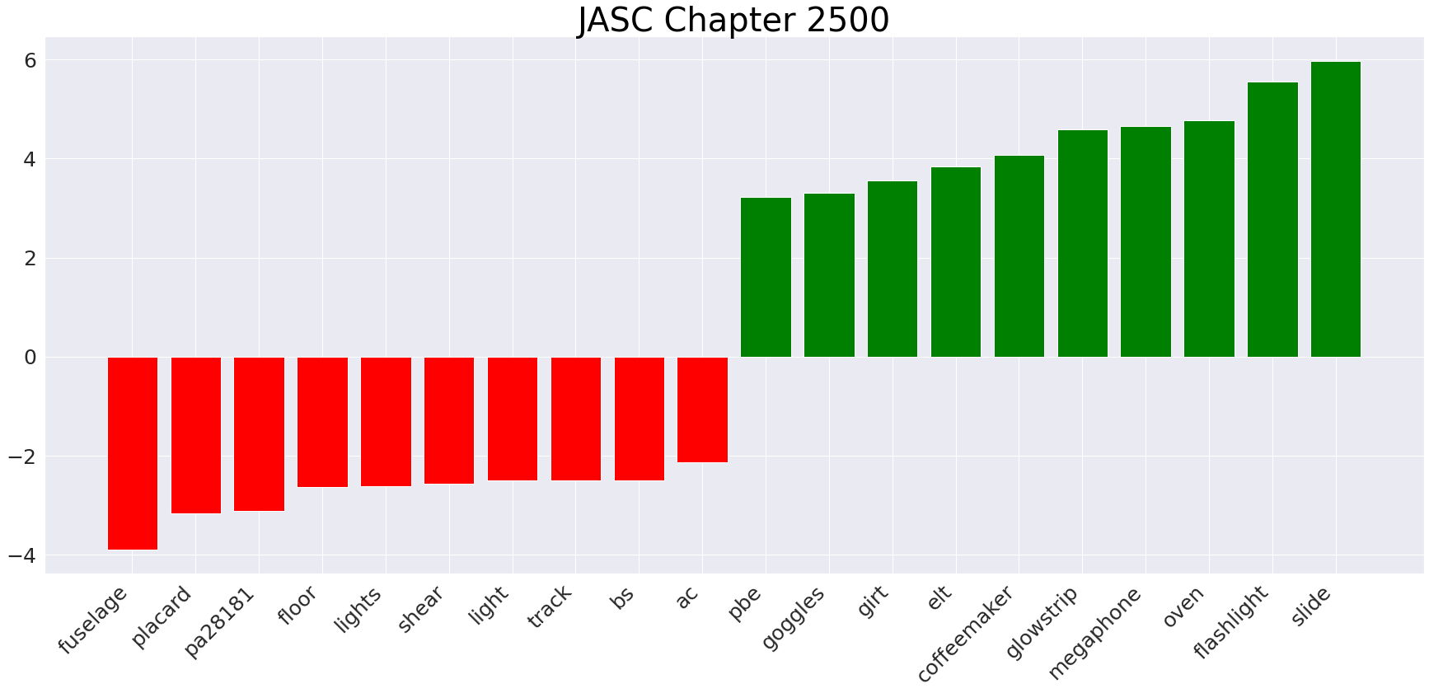The drawback of the Support Vector Machine, Linear SVC, as a classifier is missing the model explainability in terms of percentage. The FAA highly desire this output. In order to calculate the prediction probability the LIME library was included and an additional step was added from the calibration library from SKLearn was added.

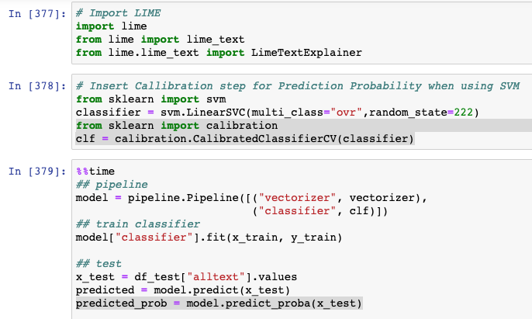

The LIME package was instantiated as a function call in the following blocks of code by first sorting the classes into order then based on the sample passed to the Analysis function, finding the index of the class for the explainer.

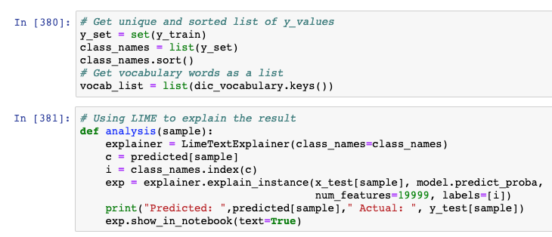

## **Gradient Boosting**

The team explored the use of Gradient Boosting and Extreme Gradient Boosting algorithms. The premise to the exploration is that gradient boosting algorithms build upon the errors of earlier trees. The goal is for machine learning to essentially learn from its mistakes to fine tune and increase accuracy. In particular, gradient boosting builds regression trees in a stepwise fashion where each tree is fit on the negative gradient of the loss function. This method took considerably more time to compute with equivalent accuracy to Support Vector Machine results.

The hyperparameters of this model were not fully explored. The initial default value of gamma, default = 0, was chosen to allow the model to overfit or seek the highest degree of accuracy. Adjusting gamma to avoid overfitting would be considered in subsequent tuning if this algorithm was selected. The max depth of the model was also taken at default. Effort was made to give the model an initial chance to learn without taking significant amount of time. However at default value the algorithm required at least 15 minutes to compute on a high end AWS SageMaker instance.

The confusion matrix of XGBoost using all the Text over the top 49 JASC Codes is shown below. As seen with Decision Tree and Support Vector Machines, the catch-all class at the bottom results in several classes being misclassified. Also in the center of the matrix there is a fair amount of confusion on those codes. This indicates that codes have more ambiguity based on the text and required fields in the SDR to fully make an accurate prediction.

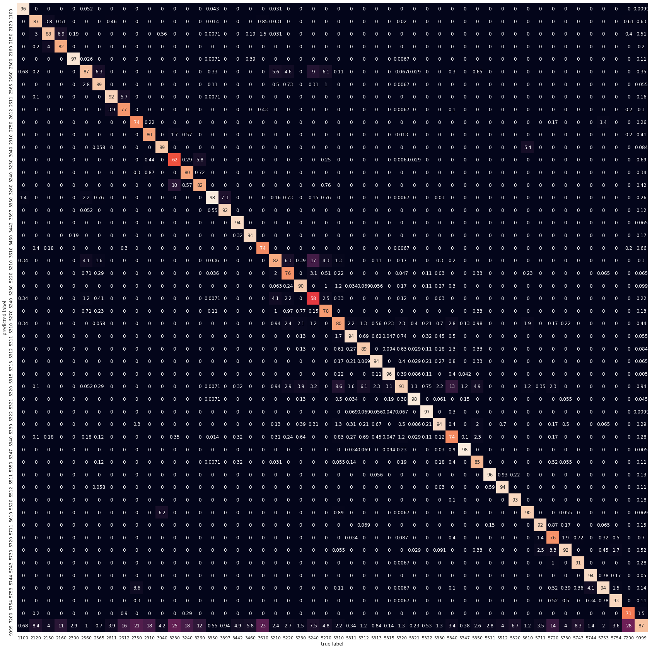

## **Other Classifiers (Random Forest, Long/Short Term Memory, and Stacking)**

The random forest algorithm was considered as an early option. Much like the gradient boosting algorithms the use of multiple learners that combine and increase the overall accuracy is appealing. Random Forest was more accurate at 92% but the additional point of accuracy came at a great cost. The algorithm required multiple gigabytes of storage to compute. Furthermore, the team was unable to complete the Random Forest algorithm on laptops similar in use at the FAA.

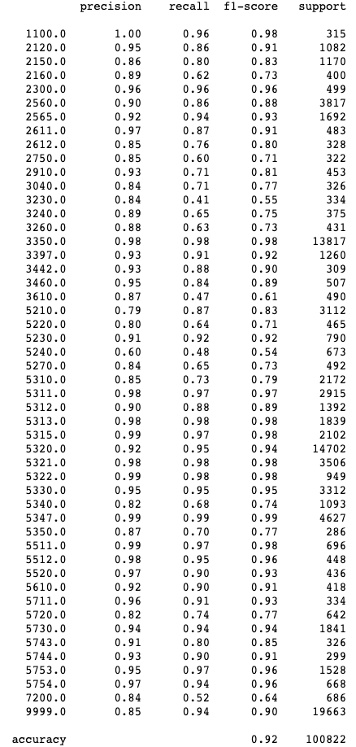

The long, short term memory algorithm uses layers of nodes where each layer signals to the next in order to drive the output layer towards the right classification. This required a reworking of the vectorization process using word2vec. The initial test of this algorithm was to combine the discrepancy and several mandatory fields in the SDR. The hyper-paraments includes an activation layer with SoftMax and the dense layer activation using Relu. There were 2 layers of LSTM and the attention layer had 15 neurons. Overall, this appeared to be a promising area based on recent research however, the nature of the SDR dataset and the computation time required focusing on the top 10 Chapters. At this level the neural network far under-performed, and more traditional and explainable algorithms were selected.

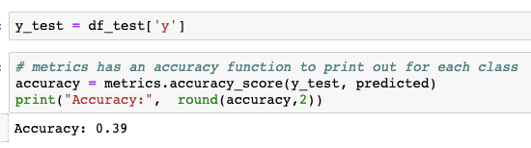

Model Stacking was an idea generated from conversations with the FAA. The premise is to use another layer of classification algorithm based on the classification algorithms on the text. This may lead to higher accuracy especially in cases where one algorithm is better at identifying a particular code. The first step is to import the model from the decision tree, support vector machine and XGBoost then run the results.

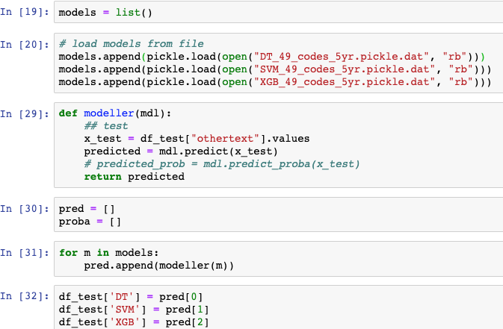

Also, the premise is to pull up out some key signals from the commonly used maintenance manuals. Overall, this was combined into a data set that was in turn split and trained using a Random Forest.

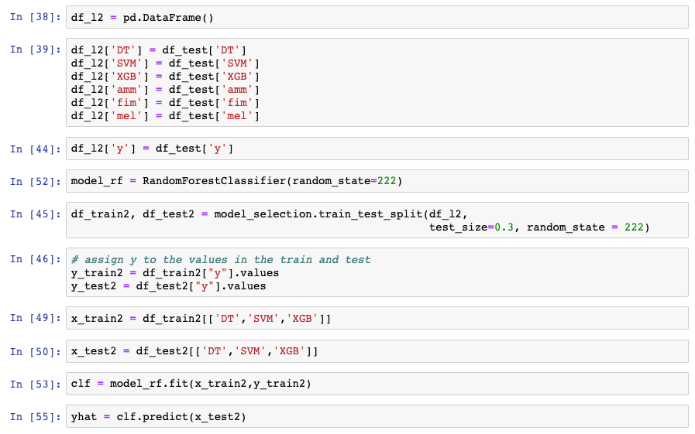

Ultimately the accuracy was not increased by any appreciable amount, 91% using SVM or XGBoost versus 92% using the stacking which would require considerably more computational time and work to implement.

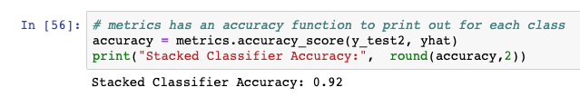

## **Algorithm Design**

The fields selected are the OTHER TEXT based on these fields being deterministic and not subject to wide variability in terms of spelling and acronyms. Additionally the top 50 JASC codes were focused on for model explainability and to reduce the bias due to infrequently used classes.

The selection of the OTHER text fields is done with the following code:

**# concatenate text from fields other than discrepancy**

data['othertext'] = data['PartName']

data['othertext'] = data['othertext'].str.cat(data['PartCondition'],sep=" ")

data['othertext'] = data['othertext'].str.cat(data['PartLocation'],sep=" ")

data['othertext'] = data['othertext'].str.cat(data['ComponentName'],sep=" ")

data['othertext'] = data['othertext'].str.cat(data['ComponentLocation'],sep=" ")

data['othertext'] = data['othertext'].str.cat(data['Nature Of Condition(s)'],sep=" ")

data['othertext'] = data['othertext'].str.cat(data['AircraftModel'],sep=" ")

data['othertext'] = data['othertext'].str.cat(data['AircraftSerialNumber'],sep=" ")

data['othertext'] = data['othertext'].str.cat(data['StageOfOperationCode'],sep=" ")

data['othertext'] = data['othertext'].str.cat(data['HowDiscoveredCode'],sep=" ")

**# concatenate text from fields other than discrepancy**

data['alltext'] = data['othertext'].str.cat(data['Discrepancy'],sep=" ")

df = data

The top 50 JASC codes were selected using the following code, relying on nlargest in the python library.

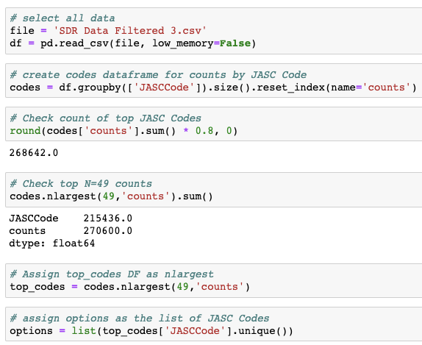

The features were selected with a count vectorizer to identify the top 20,000 features with an ngrams up to size 3. A chi-square test was used to reduce a handful of fields and produce a list of the top 10 fields for the top 50 JASC codes. This was followed by a TF-IDF vectorizer on the reduced vocabulary.

**# limits to 20,000 features (words) and uses ngram of 1 or 2 words (ngram is new and york being new york)**

vectorizer = feature_extraction.text.CountVectorizer(max_features=20000, ngram_range=(1,3))

**# fits the text into the vectors**

vectorizer.fit(corpus)

**# fits the text into vectors**

x_train = vectorizer.transform(corpus)

**# assign y to the y values of the training set**

y = df_train["y"]

**# get the feature names**

x_names = vectorizer.get_feature_names()

**# set 95% confidence limit**

p_value_limit = 0.95

**# df_features is a blank dataframe**

df_features = pd.DataFrame()

**# for each unique JASC code check if the feature and JASC code are independent**

for cat in np.unique(y):

**# compute chi-squared and get the p-value**

chi2, p = feature_selection.chi2(x_train, y==cat)

**# get the feature names**

df_features = df_features.append(pd.DataFrame(

{"feature":x_names, "score":1-p, "y":cat}))

**# sort by score**

df_features = df_features.sort_values(["y","score"], ascending=[True,False])

**# keep if over the p value**

df_features = df_features[df_features["score"]>p_value_limit]

x_names = df_features["feature"].unique().tolist()

for cat in np.unique(y):

print("# {}:".format(cat))

print(" . selected features:",

len(df_features[df_features["y"]==cat]))

print(" . top features:", ",".join(

df_features[df_features["y"]==cat]["feature"].values[:10]))

print(" ")

**# now use the limited list of features**

vectorizer = feature_extraction.text.TfidfVectorizer(vocabulary=x_names)

vectorizer.fit(corpus)

x_train = vectorizer.transform(corpus)

dic_vocabulary = vectorizer.vocabulary_

classifier = tree.DecisionTreeClassifier(random_state=222)

**## pipeline**

model = pipeline.Pipeline([("vectorizer", vectorizer), ("classifier", classifier)])

**## train classifier**

model["classifier"].fit(x_train, y_train)

**## test**

x_test = df_test["othertext"].values

predicted = model.predict(x_test)

predicted_prob = model.predict_proba(x_test)

The top 10 ngrams are included in the appendix.

## **Algorithm Selection**

The requirements for algorithm are dependent on the availability of computational power, ability to execute without sophisticated analysis and explainability. The latter was singled out as the biggest reason and this drove the algorithm selection initially towards Decision Tree. However, further analysis and an ability to incorporate prediction probability led to selecting the Support Vector Machine. Another key finding is examining the fields used in the analysis. The top 3 algorithms considered The following tables have the results for the all Chapters and the top 49 JASC Codes across the different models. Note some models such as Naïve Bayes and KNN were not included due to accuracy, the following three . Random Forest was not included due to the size of the model for rapid import and use. LSTM were not included due to the computation time required for a sample set of the data.

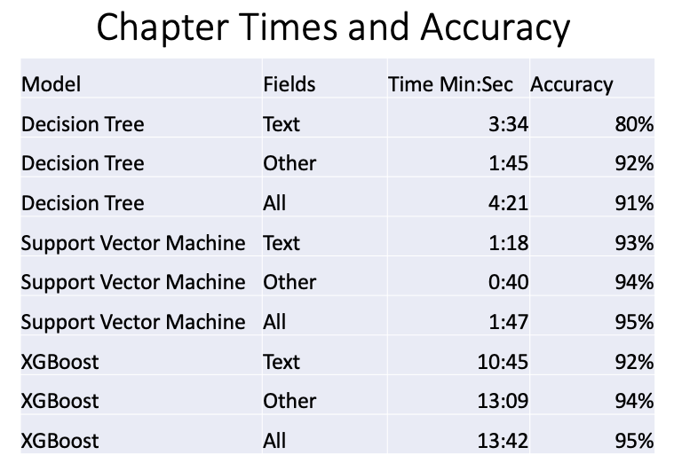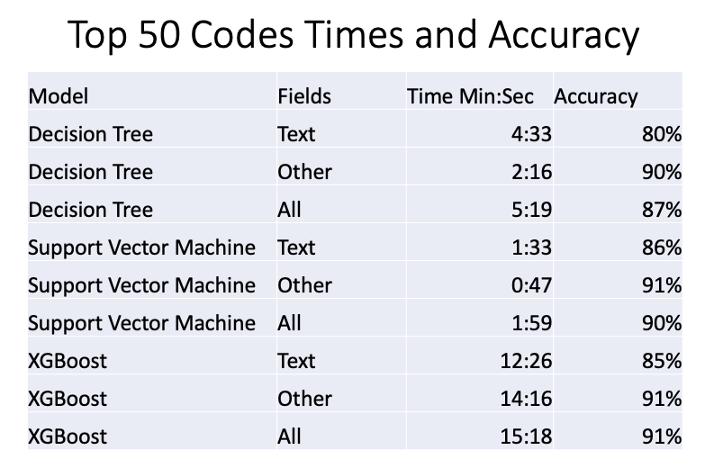

## **Algorithm Improvement**

Algorithm improvement was done on the data and cleaning stages of the data. This involves extracting abbreviations and key words from the Discrepancy field. For example, ‘passenger’ is represented by the abbreviation PAX.

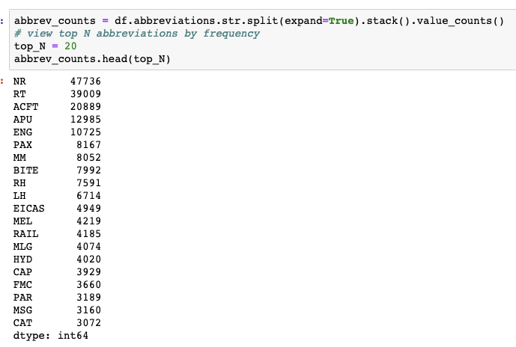

Several key words were examined with the FAA client team throughout the project. An example is a key word such as AMM 52-10-xx. This AMM acronym stands for Aircraft Maintenance Manual 52-10. In many cases the AMM number is correlated to the actual JASC code. The below output shows the number of times a keyword such as AMM is not null across the 336,071 SDRs. Incorporating an override for the Decision Tree based on the presence of a key word may further improve the outcome.

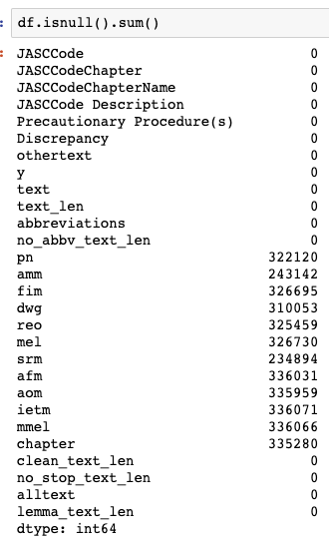

Additionally reviewing the text of the JASC code definitions and extracting keywords as an override may also increase accuracy. One such example is below where the class was labeled incorrectly and results in underperformance of a JASC code, 2560. In this case the key word Flashlight should have resulted in a label 3350.



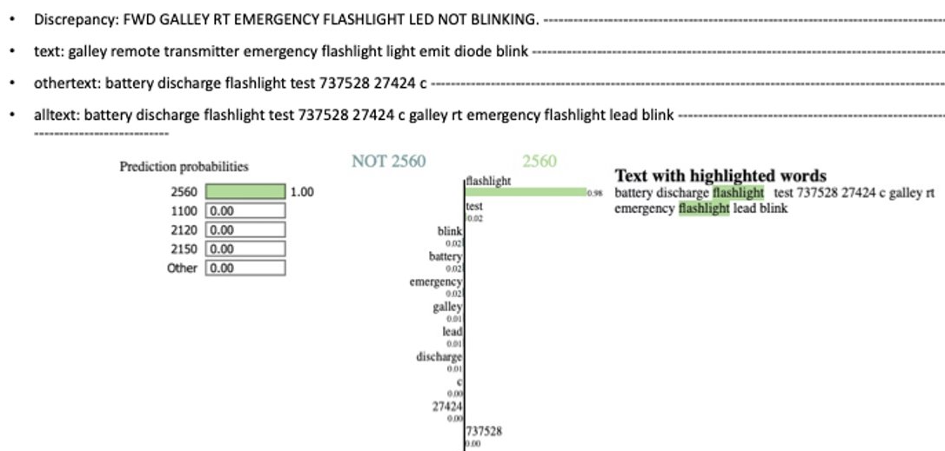

# **Visualization**

The data contained across the Service Difficult Reports was examined using exploratory data analysis techniques such as highlighting areas of imbalance, outliers, and common statistical information. Each significant finding provides an opportunity to extract the signal from the noise and present as a visual diagram. This helps the FAA team understand the data in SDRs at a macro level to identify trends and improve submissions as well as a micro level to improve efficacy in the machine learning models.

The 51 JASC Chapters occurrences exhibit significant imbalance. The seven most common JASC Chapters account for roughly ≈ 80% of all SDRs. Those categories are 5300 – Fuselage, 3300 – Lights, 5700 – Wings, 2500 – Equipment/Furnishing, 5200 – Doors, 2100 – Air Conditioning, and 5500 – Stabilizers. A total of 37 different JASC Chapters are used on less than 1% of SDRs and represent ≈ 10% of all SDRs. In fact, three of these 37 have zero occurrences, 1200 – Servicing, 1800 – Helicopter Vibration, and 8200 – Water Injection. The following Pareto chart accurately depicts this imbalance.

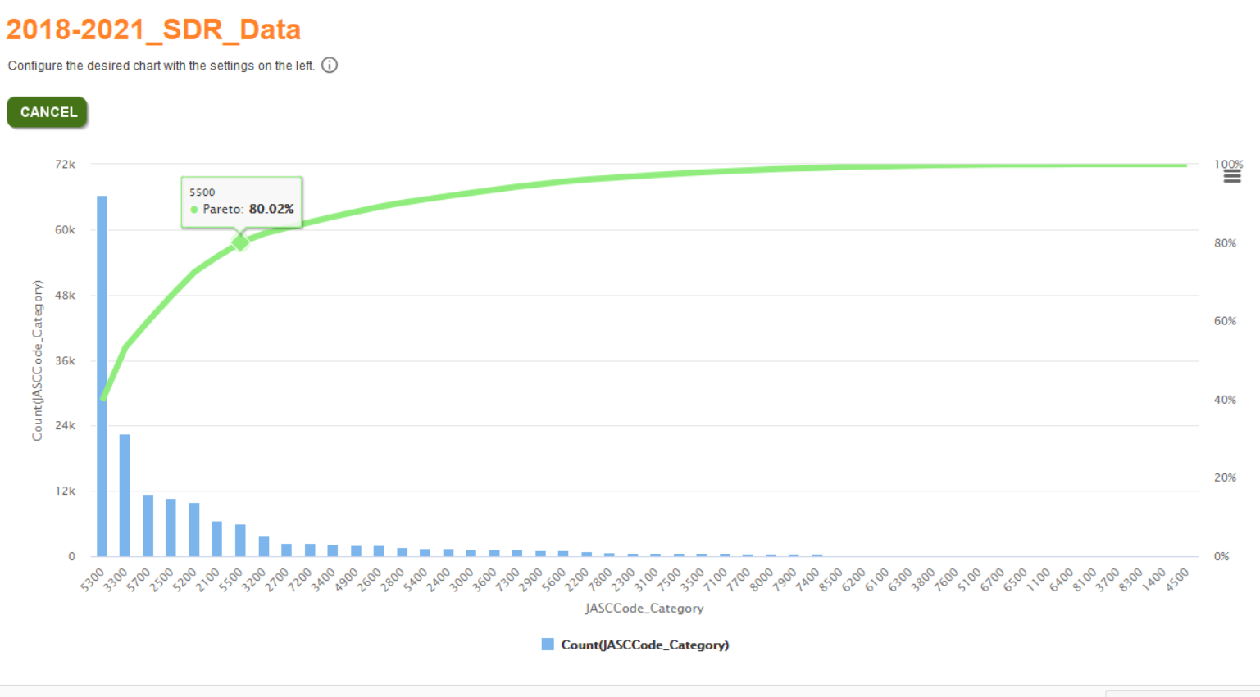

The following chart displays the JASC Chapter name instead of the numeric representation.

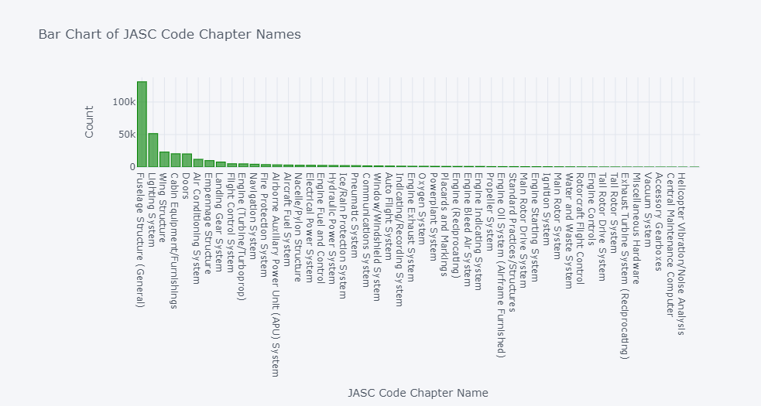

Focusing on the top values shows that JASC Chapter (Code_Category) represents nearly 40% of all the submissions. This Chapter alone is worthy of examination. Also, the low frequency of the 37 other chapters may indicate a simple means to highlight one of the infrequent chapters on submission. For example, a picklist could be used to identify the type of aircraft (jet engine, prop, or helicopter). Knowing this would eliminate some of the possible codes just based on the fact that some do not apply to all aircraft types.

The polarity of the statements is useful in determining the sentiment from all the submissions. While not core to the classification task, being able to visualize the overall sentiment may point towards an underlying theme in the SDR submissions. The Discrepancy field of the SDRs was examined in depth, the sentiment centers around Neutral as shown by the polarity being centered around zero.

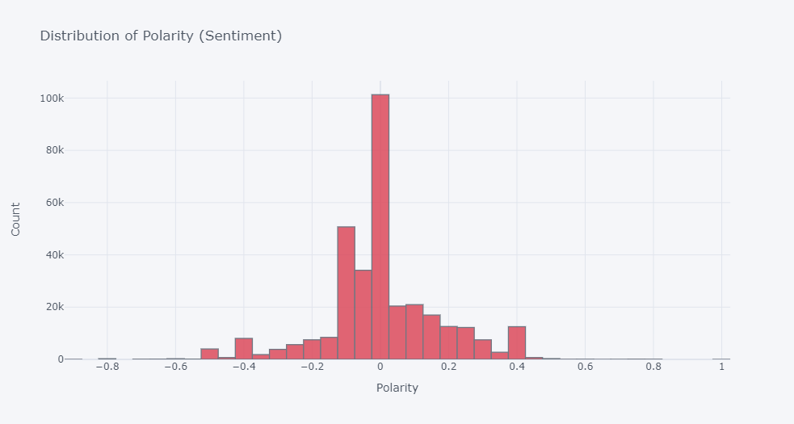

The length of words used in the submission may indicate an imbalance in technical jargon compared to more commonly used English words. The technical jargon may actually help identify Chapter and/or Code since the word may be highly specialized around a component of the aircraft. In this case, the length of words follows a normal distribution.

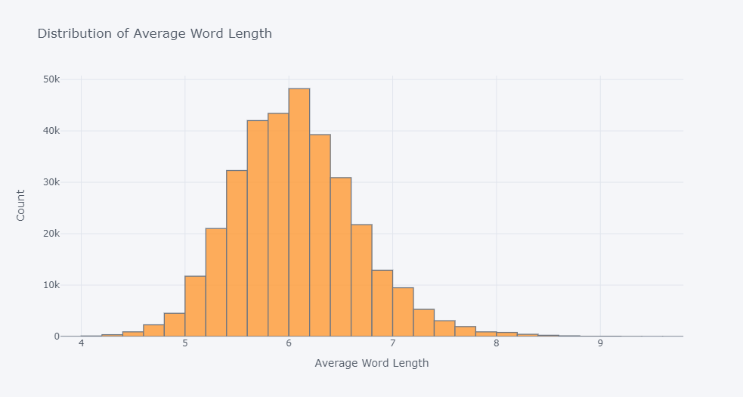

The total number of words used in an SDR submission and understanding that distribution may point to an underlying pattern. For example, if there is an outlier in the higher number of words submitted then the signal may be that certain Chapters or Codes may more often be accompanied with additional text. However, it appears that brevity in the SDR submissions is more common with the distribution more similar to an exponential distribution.

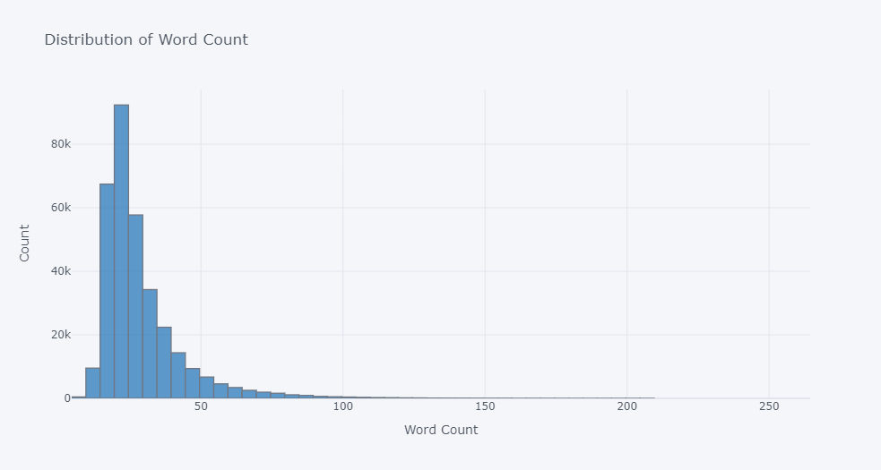

The identification of the most common words helps reduce the amount of noise in the overall text. Also, helps the FAA identify the extra data which has to be processed and then possibly ignored. For example, the SDR represents a maintenance activity and the fact that the most common words are “maintenance” and “inspection” indicates that technicians may not fully understand the utility of the Discrepancy field in indicating the unique or necessary explanation to provide more valuable data to the FAA.

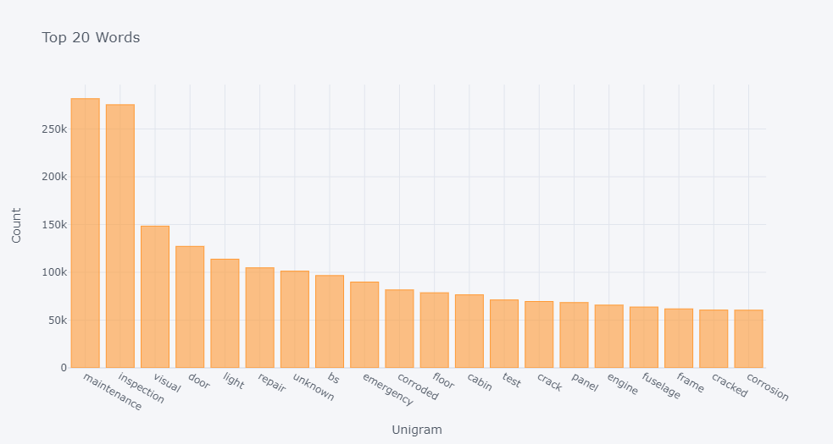

Likewise, the bigrams, grouping of words, helps to pinpoint word groups that isolate a particular Chapter or Code. Also, the grouping of words may also indicate the amount of noise in the Discrepancy field. For example “inspection maintenance” represents the most common bigram. This bigram provides little value in determining the overall Chapter and Code.

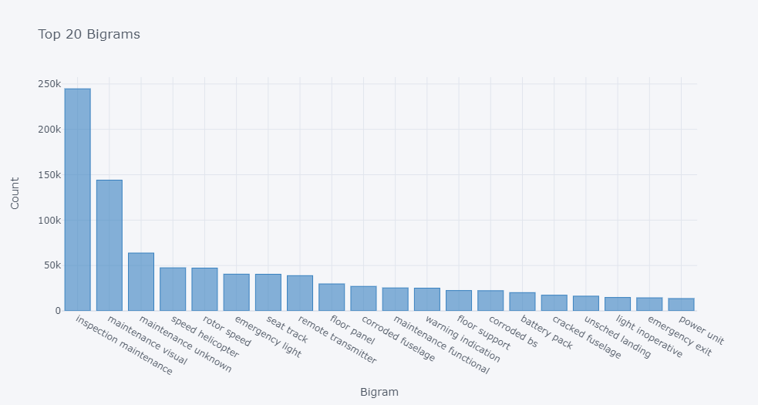

Similar to the bigrams the trigrams represent 3 words grouped together. The following chart indicates the most common of the trigrams is “inspection maintenance visual”. As noted above, this trigram provides little information about the nature of the actual SDR and component of the aircraft.

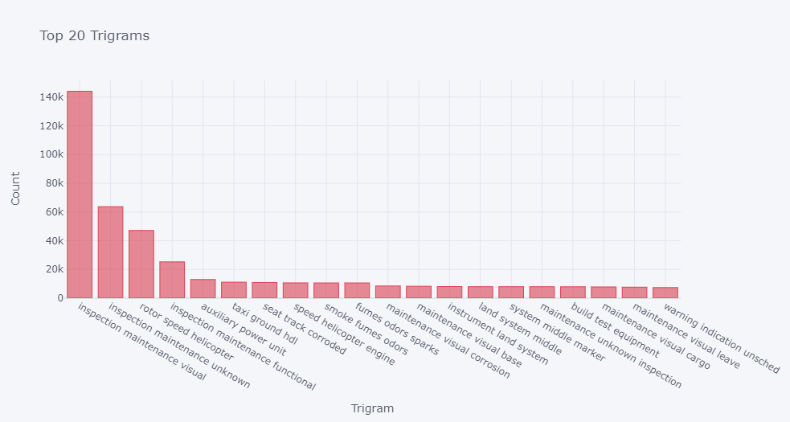

The part of speech is a useful analysis since certain parts of speech indicate information or descriptions instead of verbs which indicate an action. The more descriptive the terms in the Discrepancy field the more useful those words will be to ultimately identify the Chapter and Code. Here the number of nouns and numeric cardinals may provide a wealth of information.

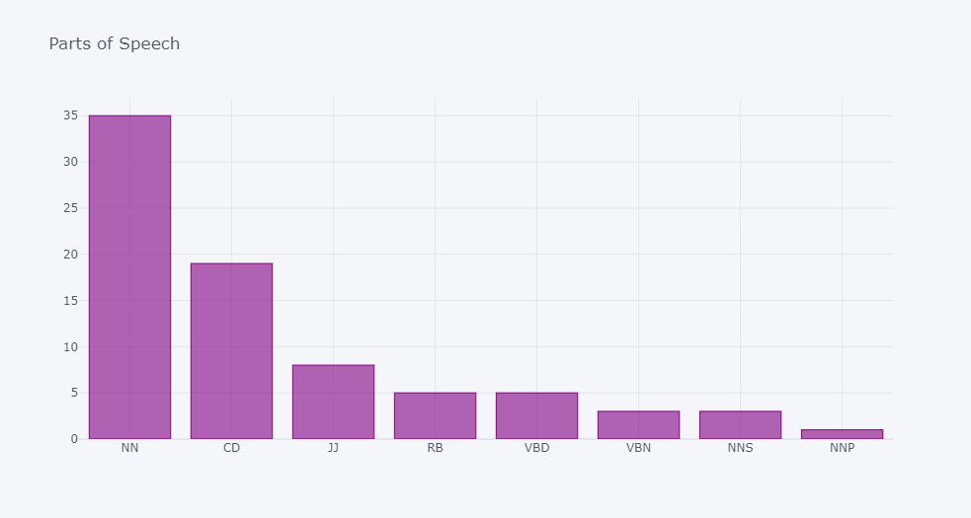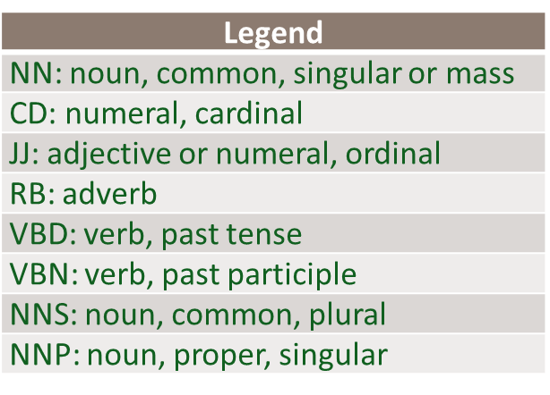

Pairs plots can be a useful method to identify relationships between variables. For the purposes of this project, however, the variables of interest were categorical variables, not numeric. The variables indicating a strong relationship below are expected because in most cases are derived from other fields.

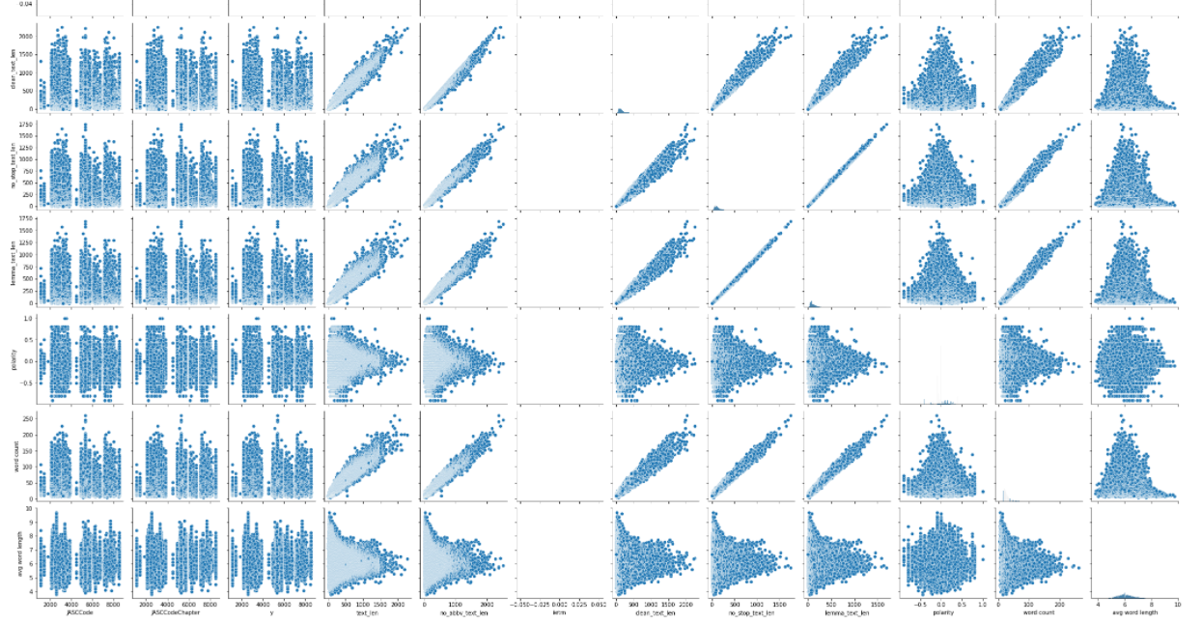

This visualization is utilizing box plots that represent polarity across the JASC Code Chapters. The distribution for Chapter 3300 is significantly higher than the other chapters. This chapter was also predicted with a high accuracy, nearly 99%.

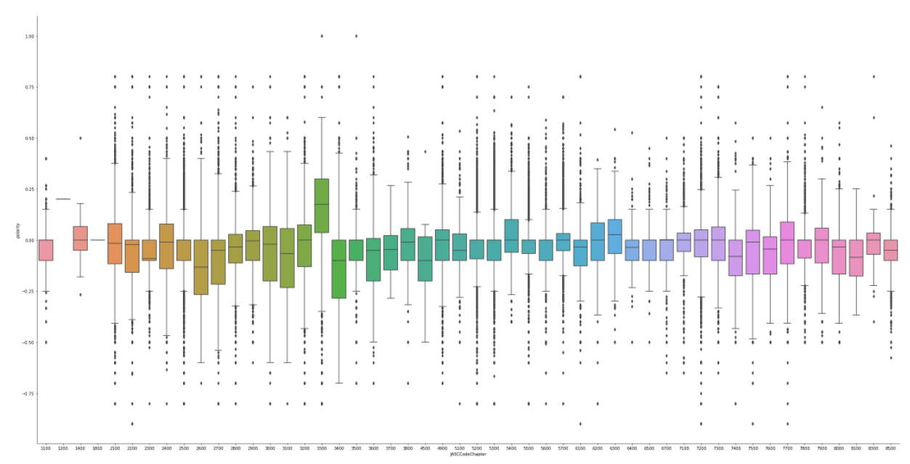

This visualization is a kernel density estimator. It is estimating the probability densities of the average word length and polarity fields and visualizes them in a contoured map identifying probabilities.

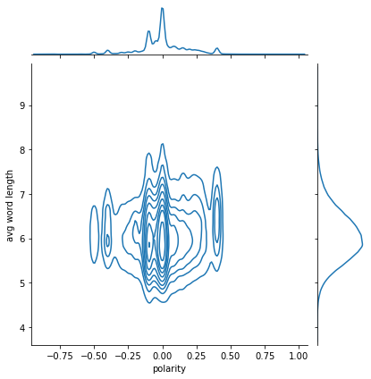

This graph is a stacked bar graph that illustrates which JASC Codes (and JASC Code Chapters) the MEL, AMM, and FIM extractions are found in.

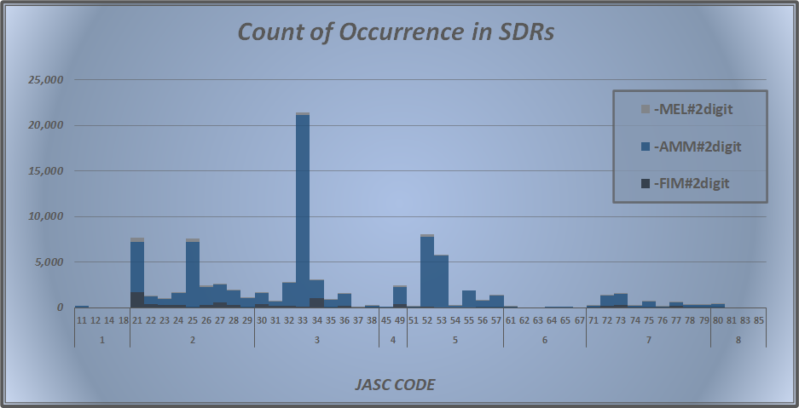

This graph is a simple bar graph that illustrates extraction frequency of occurrences in SDRs. References of SRM and AMM occur in nearly 30% of SDRs, while other extractions occur less frequently.

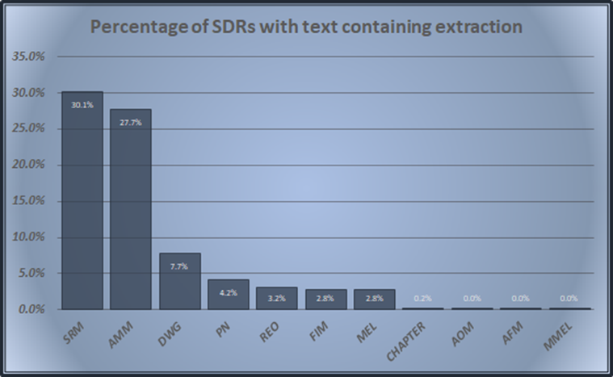

The table below was used to identify the correlation between extractions and the JASC Code. Note that the correlation was calculated for five different levels of the extraction and JASC Code.

* Level 1: Correlation between the full JASC Code (four digit) and the complete extraction (extraction and all of the digits that followed, if any)
* Level 2: Correlation between the first digit of the JASC Code and the extraction with the first digit
* Level 3: Correlation between the JASC Code Chapter (first two digits) and the extraction with the first two digits
* Level 4: Correlation between the first three digits of the JASC Code and the extraction with the first three digits
* Level 5: Correlation between the full JASC Code and the extraction with the first four digits

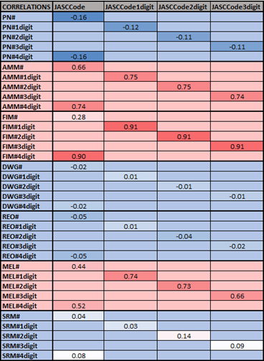

This was used to explore if they provided value in predicting the JASC Code, if there was an optimal number of digits to extract, as well as to identify any extractions that appear to provide more value than others in the prediction. Based on this, it appears that AMM, FIM, and MEL extractions are correlated with the JASC Code Chapter (first two digits) and that extracting any more than two numbers after these references does not provide increased value.

The visualizations below are items that were discovered throughout the algorithm design and selection process. The 90%, 95% and 99% threshold were used to select features and run through a decision tree algorithm for comparison across the top 10 JASC chapters on accuracy. Each threshold and the number of features is listed below.

90% Variance = 47 Features

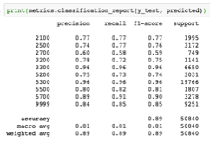

95% Variance = 203 Features

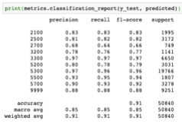

99% Variance = 885 Features

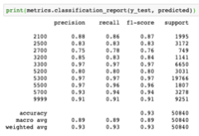

A comparison using a Decision Tree at the top 10 JASC Chapters indicates that the mandatory fields selected by the technician produces the most accurate classification 95% versus 90% with Discrepancy and 94% with all text.

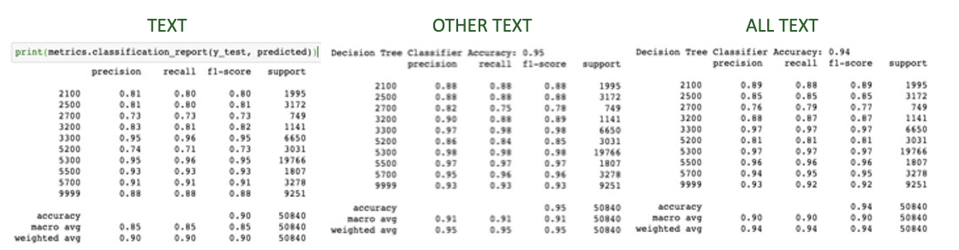

The accuracy of the initial learning of Naïve Bayes on the JASC Chapter was approximately 89%.

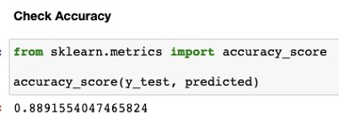

The K-nearest neighbors was recomputed with the top JASC codes accounting for approximately 80% of the total number of SDRs. This was considered to provide a view of the most used JSASC Chapters and determine a baseline for an algorithm which will automatically select a JASC code and other codes which should be manually assigned given these JASC chapters and codes are not frequently assigned.

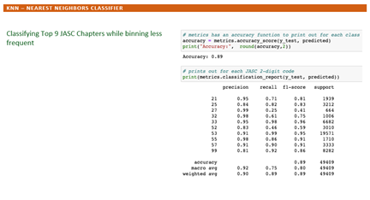

The Support Vector Machine has

Decision Tree Classifier confusion matrix shows a handful of JASC chapters which are difficult to identify such as Chapter 14 and 83:

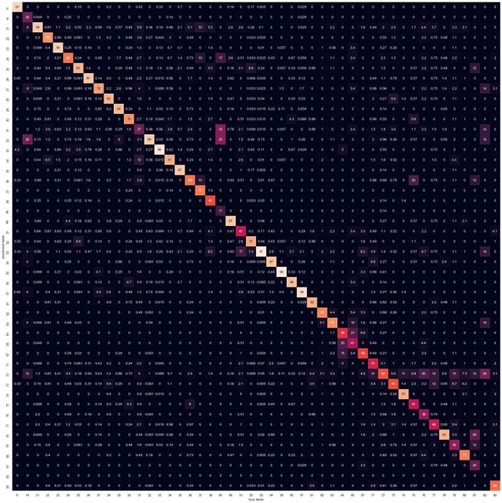

Decision Tree with default parameters produced an accuracy of 90% on the fields using only the ‘othertext’ field confusion matrix:

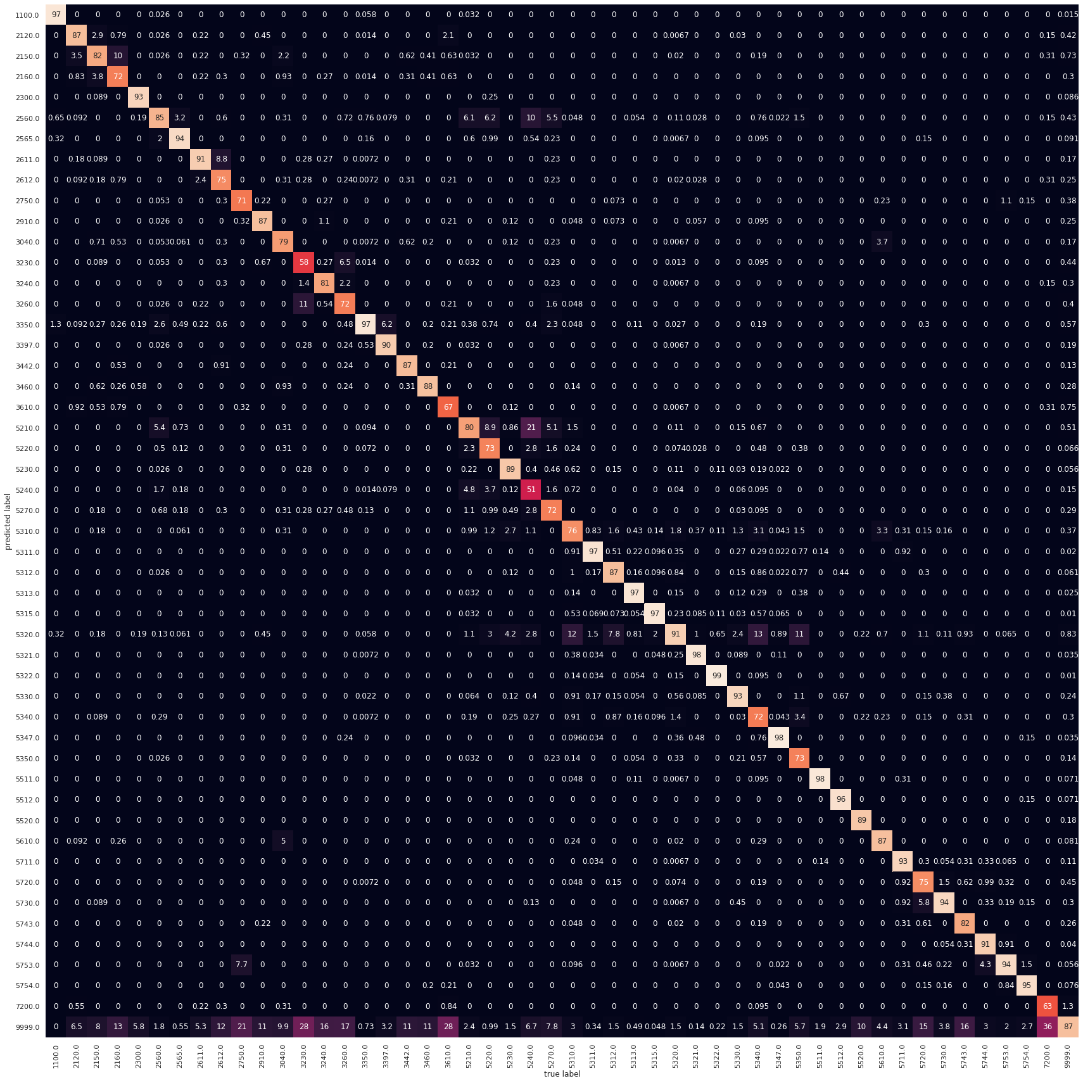

Initially the Decision Tree Classifier was examined because it achieved a high rate of accuracy and explain ability. The Decision Tree across all the 4-digit Codes was done with an accuracy of approximately 79%. The number of codes precludes displaying a Confusion Matrix and the following table has an excerpt for the precision, recall, F1 and support for the first 20 codes.

4-digit JASC code using the Decision Tree Classifier:

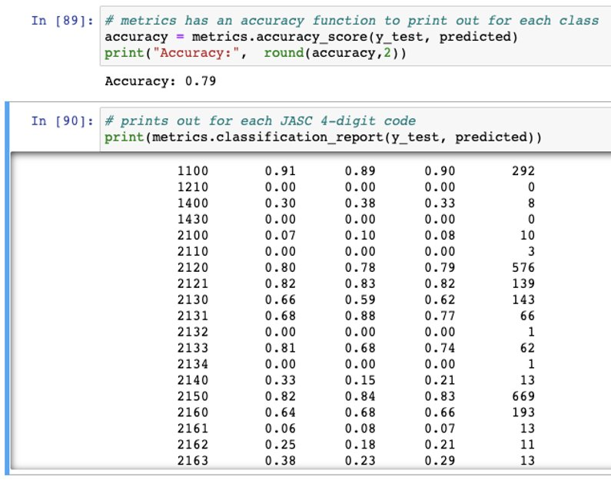

The performance of the Support Vector Machine on the JASC Chapter was also done. The confusion matrix shows that most of the Chapters were predicted with a high degree of accuracy while a handful of less common Chapters were missed.

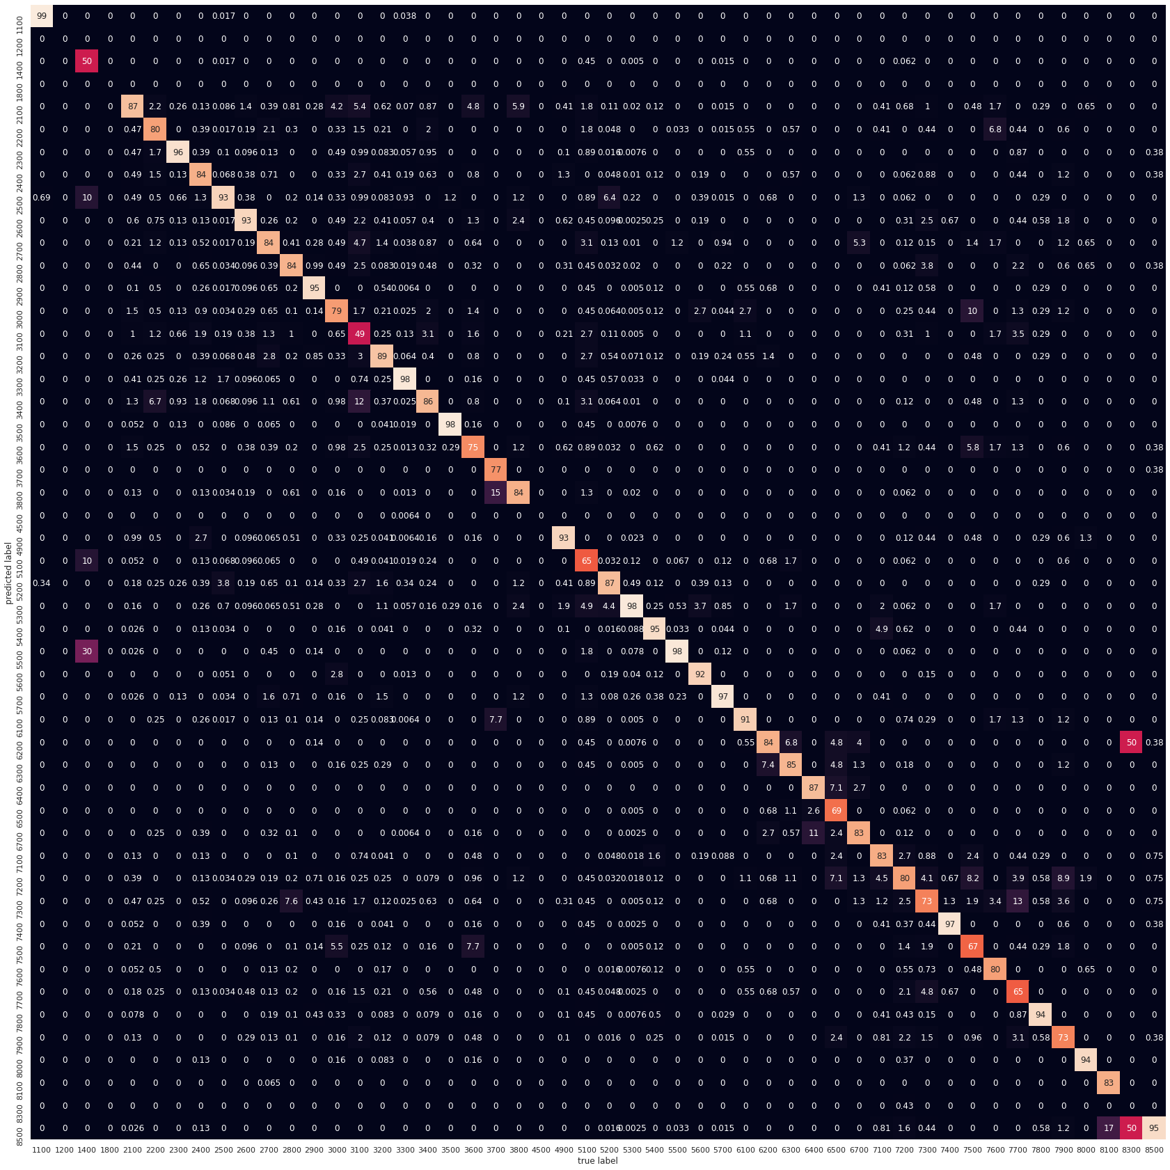

The performance of XGBoost Classifier was also done. Similar results as seen with SVM and other classifiers. This confusion matrix is very similar to the others while a few exceptions are noteworthy such as the 100% accuracy with Chapter.

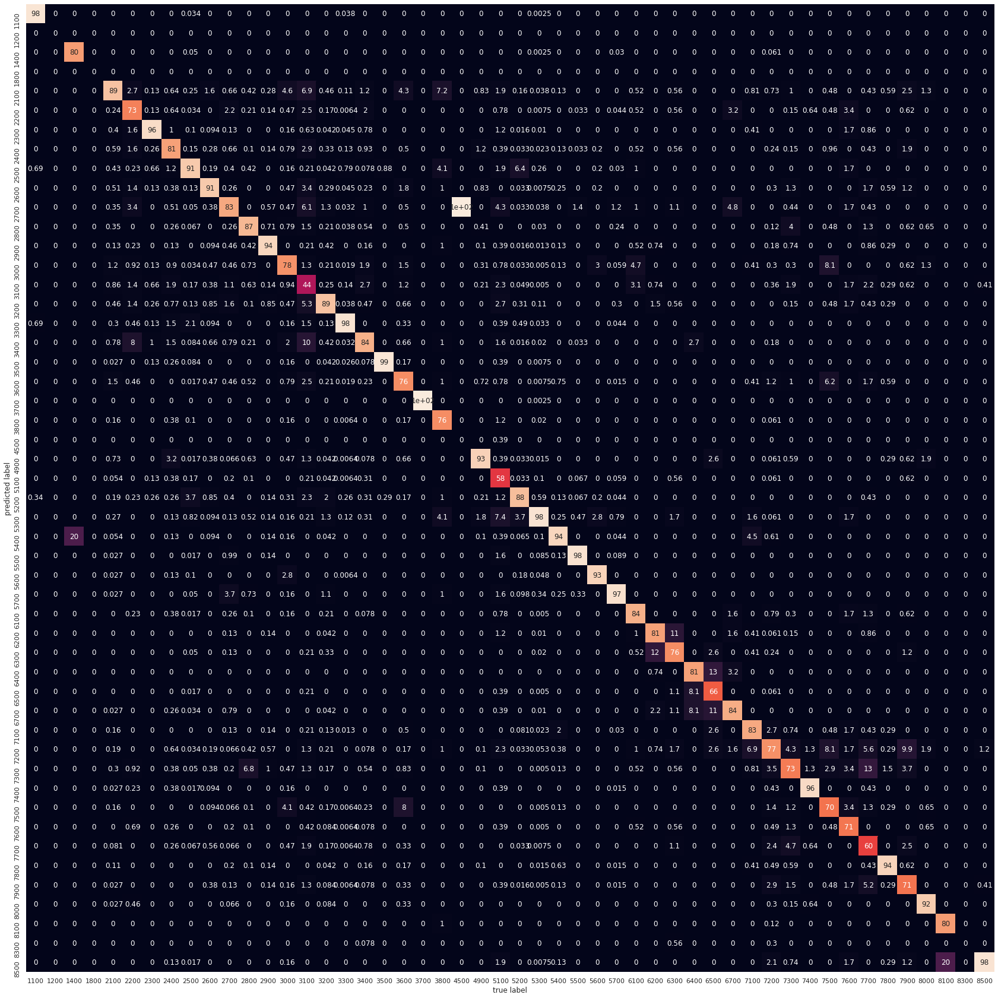

Another analysis was performed focusing on the top 10 JASC Chapters. The expectation is to analyze chapters with roughly the same level of support and then create a bucket of less commonly seen Chapters for another stage of classification. This method produced very high accuracy on the top 10 Chapters.

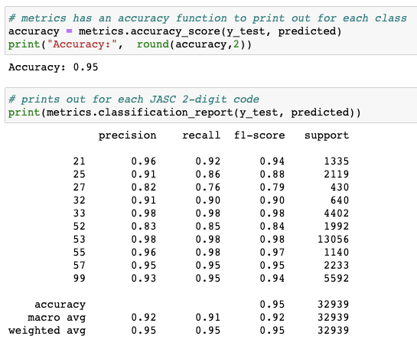

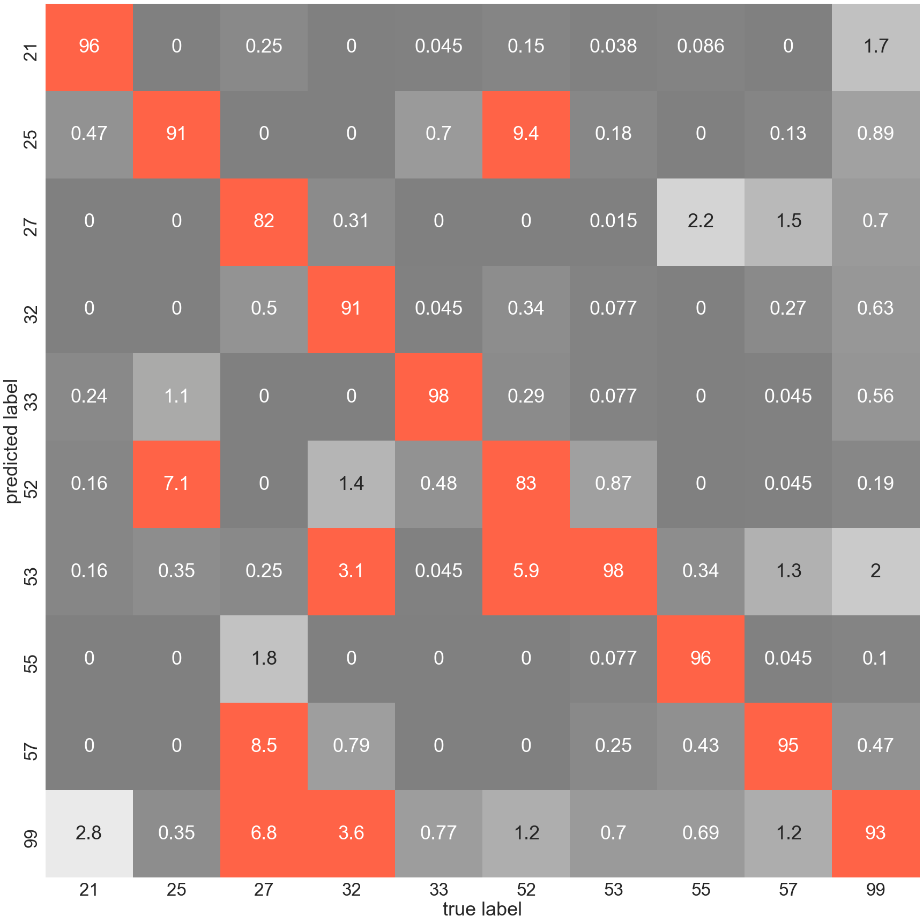

Overall, the goal of stacking the output of each type of model was done. The expectation is to find a code or chapter that is predictably wrong in some classifiers and right in others. This approach led to analyzing the Gradient Boosted Classifier and Support Vector Machine shown below. Ultimately stacking failed to produce any gains. Random Forest or even another round of XGBoost as next level classifiers failed to pinpoint errors in other models and increase the outcome. Shown below are the confusion matrix from Gradient Boost and SVM.

Gradient Boosted (accuracy 88%):

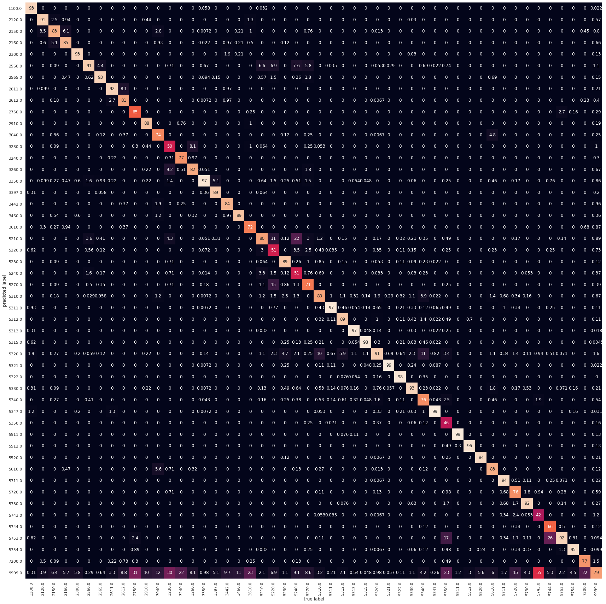

Support Vector Machine produced an accuracy of 92%.

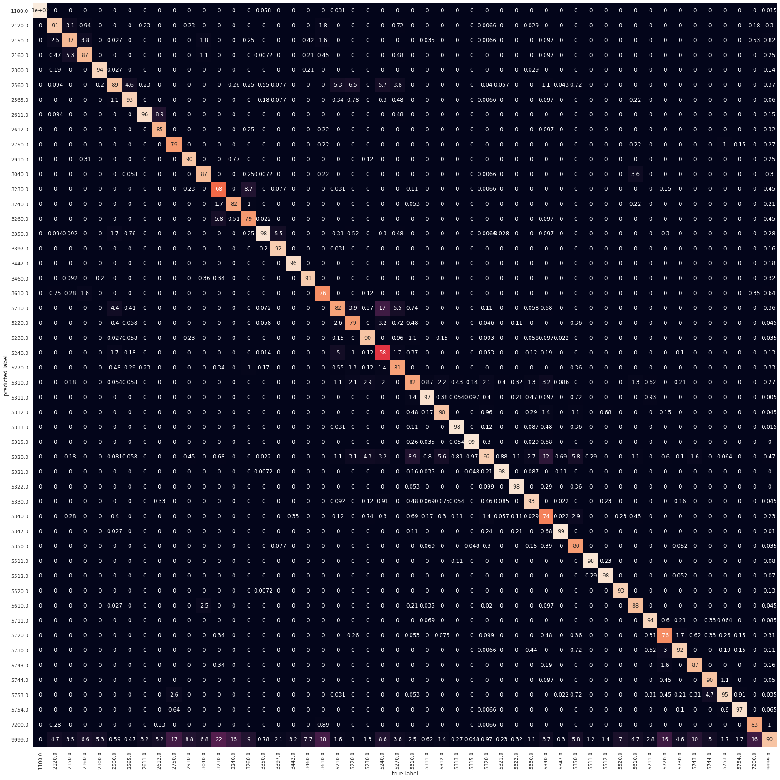

The feature importance of the SVM model, highest shown above. Indicates several key words that heavily influence this model. In combination with word clouds charts such as the word importance shown below would help train any personnel performing manual coding of SDRs.



Model explainability is a key requirement for the FAA. The precision of a prediction and understanding how accurate the selection is will be a factor in driving adoption. The package LIME produces explainable results looking at the feature names, class names, and model.predict_proba (prediction probability). These results make sense where the machine learning model has some ambiguity of the choice to be made. However, in the case of some models the machine learning algorithm is 100% confident as it was with SVM. In order to produce some probability a cross fold validation step was added. This output produces a result that is compelling for the FAA to understand the selection the model made based on the words in the othertext field.

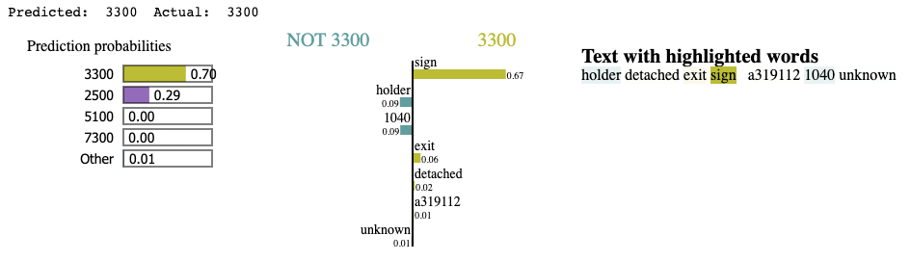

# **Findings**

From the onset, the intent was to use machine learning to classify SDRs into pre-defined two-digit JASC Code Chapters and four-digit JASC Codes. To that end, our SVM model classifies SDRs into JASC Code Chapters with an accuracy of 93% using just the discrepancy field on the report. This means that the model classifies an SDR into the same class it was assigned to using the manual process currently implemented. The confusion matrix below illustrates how the model performs better for some classes while underperforming for other classes. For classes reported considerably less often than others, it is much more difficult for the model to provide an accurate classification. Furthermore, it appears there are some classes – or groups of classes – that may have less distinct boundaries leading to misclassifications falling into one or more of its nearest neighbors.

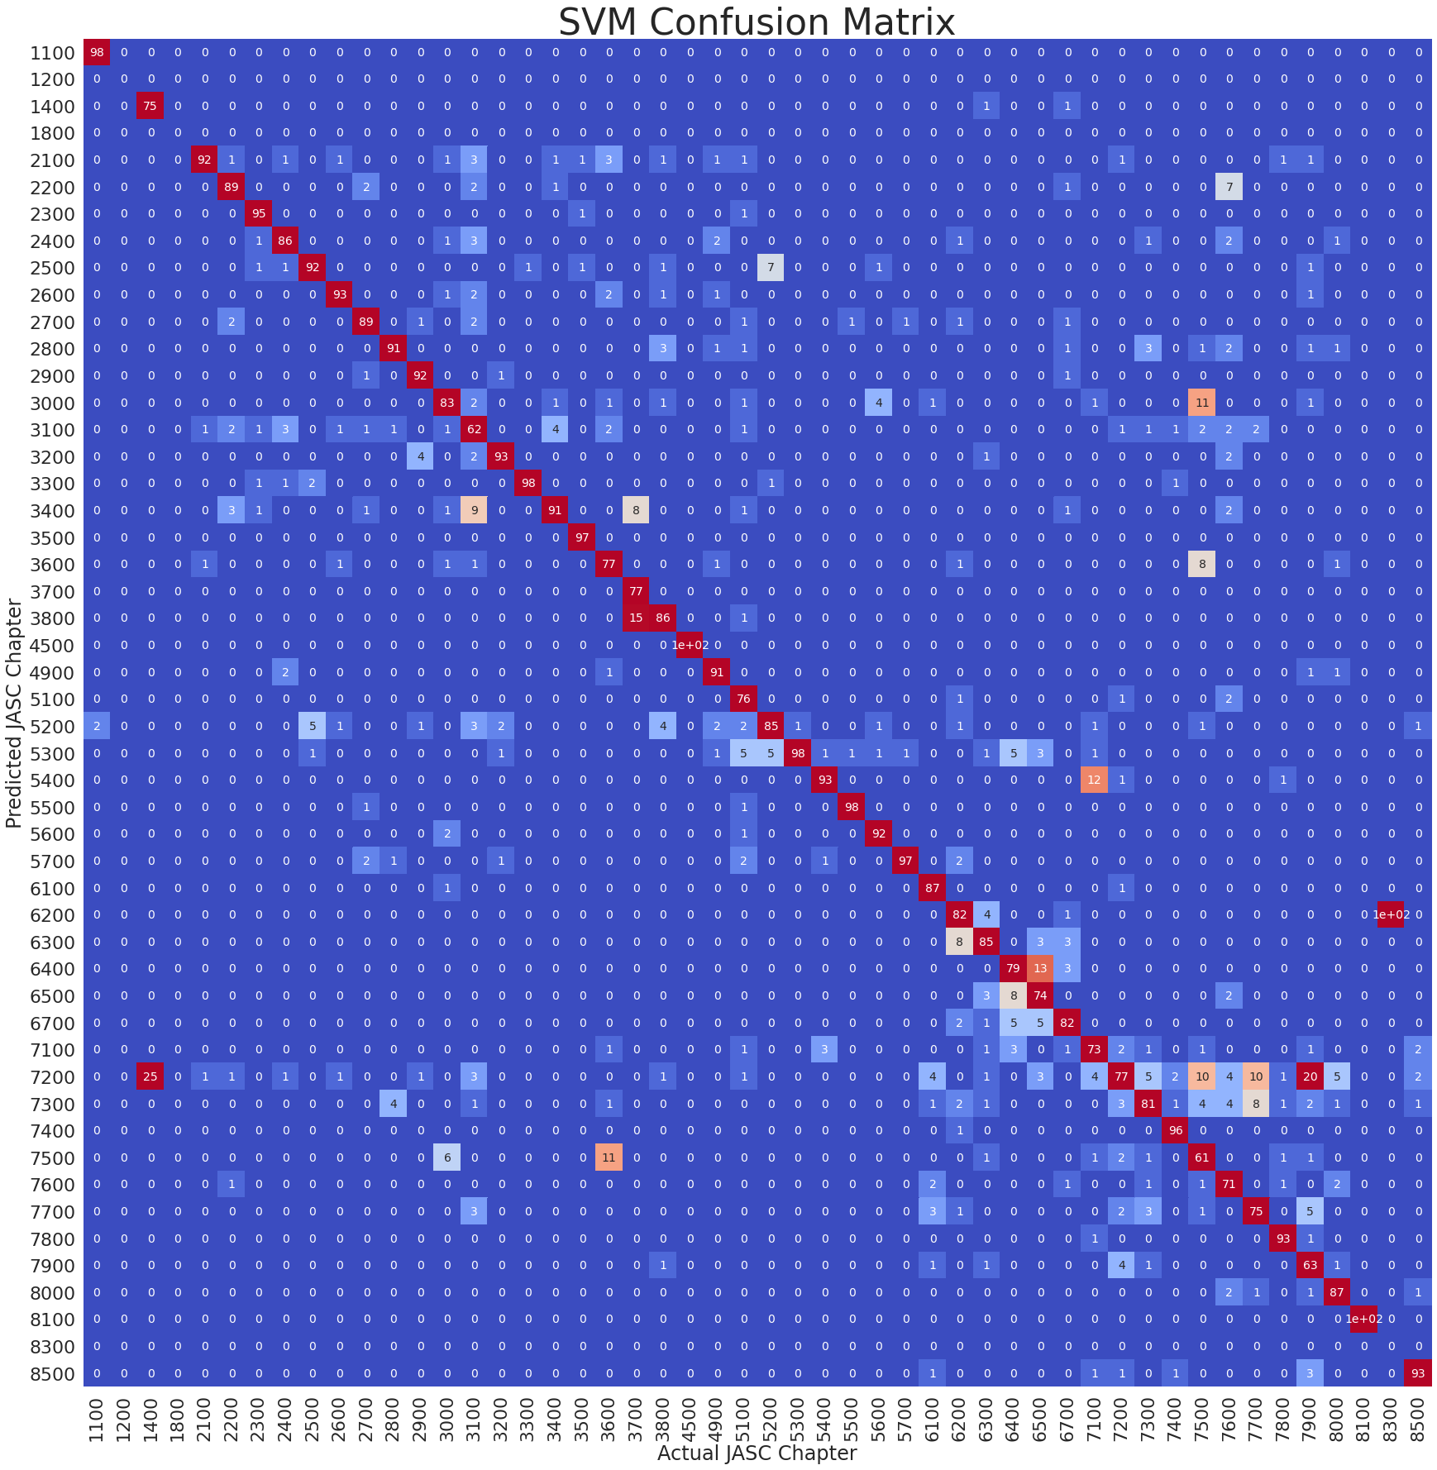

Attempting to explore the impact the apparent class imbalance has on performance, several different models of varying types were explored and provided similar outcomes to different approaches to the bigger picture problem of classifying SDRs into the JASC Code structure. Ultimately, a number of different model types produced results similar to that of the SVM model. The confusion matrix below uses the same SVM model used above to classify SDRs into one of the top 80% of four-digit JASC Code or an ‘other’ bucket comprised of all of the other less frequently utilized four-digit JASC Codes, using the ‘discrepancy’ field and the input. Approaching the problem from this point of view provides relatively accurate predictions for the most common JASC Codes while providing a method to identify a group of SDRs that are more likely to be classified as a less common JASC Code. Establishing a system where reports classified as a JASC Code included in the group of lesser common codes are marked for manual review could significantly decrease the workload without sacrificing overall performance.

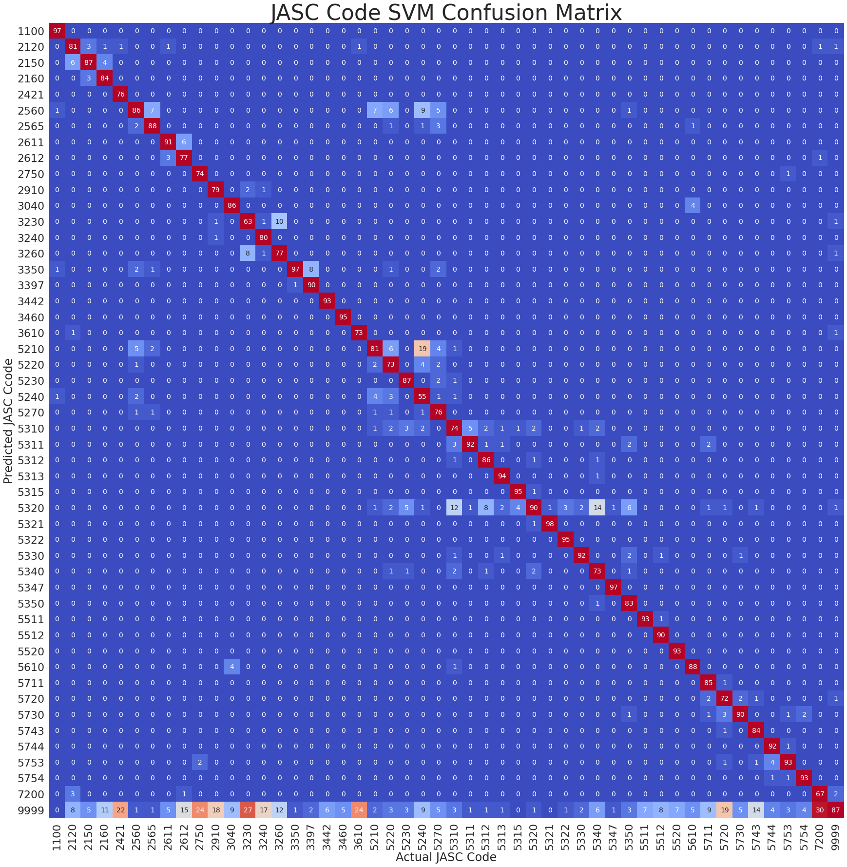

# **Summary**

Classifying SDRs into JASC Codes includes many intricacies that contribute to a challenging and difficult process. Using machine learning models can be an effective alternative to methods currently in practice today. Models are capable of classifying SDRs into JASC Code at a relatively accurate rate. The ‘discrepancy’ field has traditionally served as the field holding most significance. However, this is most likely a function of the current process. That is, a process driven by manual efforts working within a current system of constraints. It is more efficient and effective for an individual tasked with processing and classifying a large number of SDRs into JASC Codes to simply read the text found in a single field as opposed to learning and memorizing all of the different patterns that exist in the other fields. Machine learning models are not only capable of doing the same task, but they are also capable of picking up on these hidden patterns and relationships that exist in the other fields – and more often than not, do so with better accuracy.

# **Future Work**

Some abbreviations and acronyms are found in the comments more often than not. The list was improved by identifying items in the list that needed to be removed because they were the same as other commonly used words. Some, although commonly used in the aviation industry do not make sense to substitute. For example, substituting the word ‘and’, or ‘if’, with the industry specific definition does not make sense and could lead to incorrect results. A more verbose and project specific list of stop words was created and frequently updated based on reviewing word frequency distributions and word clouds with individuals that have industry specific knowledge and experience. Many SDRs contain numerical references to specific items. Some of these references occur in certain JASC Codes and JASC Code chapters more frequently than others and some references appear to have a stronger correlation to JASC Codes than others. Exploration and routine audits of these lists may provide additional value.

Utilizing all the different model outputs (confusion matrices, Lime outputs, performance metrics, EDA, etc.) it appears as though there are some patterns to be discovered within the models’ misclassifications. Some misclassifications are more understandable than others when reading the text used in its stated definition. Many of the commonly misclassified codes include a detailed list of everything that belongs in its class and then lists something that if listed, although very similar, suggests that report is for an entirely different code or chapter. Items in definitions that directly call out items that do not belong to a given class and are often similar to other features within the class but are explicitly calling out that they belong in a different class. This can not only contribute to increased misclassifications in the model, but they likely confuse individuals who currently conduct the code classification process manually. Language in the definitions such as this most likely contribute to misclassification errors in both a human driven process as well as a machine learning based model. Reviewing current definitions with individuals currently tasked with classifying SDRs, and those who fill them out, would be valuable. For the same reasons, it isn’t too unreasonable to assume the SDRs already processed could have been misclassified. Auditing previous SDRs from frequently misclassified chapters as a method to verify reports were classified correctly could be something worth exploring.

Using findings from the project as well as from any future work could be used to enhance the report itself. Picklists in the fields other than the discrepancy field could be reviewed and updated. Fields that have a picklist where the most common selection is ‘other’ or ‘unknown’, information found in those SDRs could be used to improve the picklist options. Similarly, information found is SDRs could be used to identify if adding a new field could be useful. Examples may include a field for references to manuals, or a field that attaches previous, related, or reoccurring issues to each other. The actual report generation process could be refined by using the specific definitions of JASC Codes to drive the sequence and logic of the report generation process. Using a touch screen application that drills down into aircraft sections and components based on a series of specifically directed questions could be one approach. For example, driving a few cascading report questions similar to something below could help improve results:

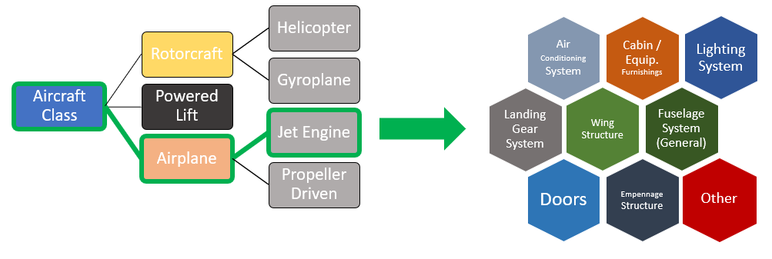

Someone filling out this information and then selecting from one of the options would correctly classify more than 80% of all SDRs directly into the chapter level while grouping some of the lesser common ones into a ‘other’ bucket. A subsequent menu might include questions surrounding any chapters that frequently get misclassified into the selected chapter providing a layer of validation to catch any common misclassifications before they happen. For example, JASC Chapter 25 (Equipment/Furnishings) and JASC Chapter 52 (Doors) are frequently misclassified as one another and into a few other chapters. Upon reviewing their respective definitions, it becomes easier to understand why and where some of the misclassifications might occur. Creating a question, or selection(s) from a picklist, could be used to ensure the appropriate classification was made.

|  |  |  |
| --- | --- | --- |
| 2540 | Lavatories | The units and associated systems and parts located in lavatories. Does not include wash basins and other waste disposal items in JASC code 3830. Typical parts are trash containers, dispensers, etc. |
| 2550 | Cargo Compartments | The compartments for the storage of baggage and cargo including external mounted pods. Does not include the exterior door, hinges and latches which are filed in JASC code 5230. Typical parts are tie downs, restraint nets, and equipment for loading and unloading cargo (includes external load handling equipment). |
| 2560 | Emergency Equipment | The components, parts, and systems carried for emergency use other than those specifically referenced in other JASC 2500 series codes. Does not include fire extinguishers, oxygen equipment, and flashlight. Flashlights are filed under JASC code 3350. Escape slide girt bars are filed under this code. |
| 5270 | Door Warning System | The system which is used to indicate to flight crews whether the exterior doors are closed and properly latched. Does not include the landing gear position warning indications which are covered in JASC code 3260. Typical parts are switch, lamp, horn, relay, etc. The suspect door should be identified if known. |
| 5280 | Landing Gear Doors | For reports pertaining to the structural aspects of landing gear doors including hinges and seals on the wing, landing gear, and fuselage mounted doors. The door position on the aircraft or landing gear (i.e., nose, right main outboard, etc.) should be shown in the part location field. Does not include the operating mechanism or position indicating or warning system which is filed in JASC codes 3231 or 3260. |

# **Appendix A: Code References**

[*https://github.com/GMU-DAEN-NLP-NINJAS/Final*](https://github.com/GMU-DAEN-NLP-NINJAS/Final)

# **Appendix B: Risk Section**

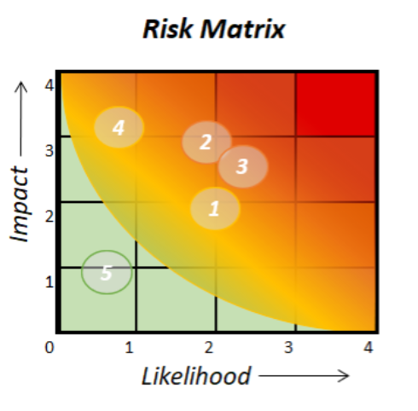

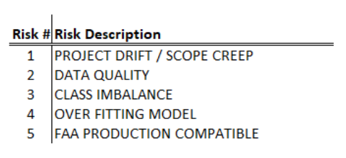

|  |  |  |  |  |
| --- | --- | --- | --- | --- |
| **Risk Name** | **Description** | **Probability** | **Impact** | **Mitigation** |
| **PROJECT DRIFT / SCOPE CREEP** | Ambiguously defined or additions to scope leading to uncontrolled expansion of project scope without adjustments to time and resources. | Likely | Moderate | Weekly meetings with customers; YouTrack; Communicate concerns |
| **DATA QUALITY** | Terms, codes report, and use not uniform across industry. Data sourcing methods may unintentionally duplicate rows when merging multiple smaller data set downloads into a comprehensive data set. | Likely | Moderate - Major | Focus on identification of this class of JASC codes that would require manual intervention |
| **CLASS IMBALANCE** | Current system often misclassifies a few categories. | Very Likely | Moderate | Focus on single carrier that produces higher quality |
| **OVER FITTING** | Over fitting models can lead to misleading findings and degradation of model utility over time.  Model cannot be too tailored to specific data set. | Not Likely | Moderate – Major | Identify applicable and consistent evaluation metrics for model(s) utilized.  Increase dataset from 3 years of SDR to 5 years.  Test with independent set. |
| **FAA COMPATIBLE PRODUCT** | FAA policies limit the list of approved libraries, packages, environments, software, etc. | Not Likely - Likely | Minor | Use it to increase familiarity and ask questions as needed |

# **Appendix C: Agile Development**

*Agile Development – workflow*

# **Appendix D: Top ngrams for each JASC code**

# 1100.0: . selected features: 975 . top features: 10060,10064,10067,10070,10104,10106,10117,10132,10138,10153

# 2120.0: . selected features: 1683 . top features: 100 smoke,100 smoke fume,1104,1217,2201,2470,2473,2567,26950,2698

# 2150.0: . selected features: 2535 . top features: 24318,24318 tx,2473,25132,25132 nr,25864,25864 cr,25864 nr,26265,26265 cr

# 2160.0: . selected features: 1562 . top features: 24318,24318 cr,24318 nr,27611,27611 cr,27959,27959 nr,28865,30110,30110 cr

# 2300.0: . selected features: 1083 . top features: 35091,35091 nr,35091 tx,35103,35103 nr,35107,35107 nr,35107 tx,35177,35177 nr

# 2560.0: . selected features: 4926 . top features: 100,10058,10104,10109,17000388,17000394,17000398,17000412,17000414,17000419

# 2565.0: . selected features: 2901 . top features: 1038,1040,1196,27701,27929,28707,29812,34479,36660,4242

# 2611.0: . selected features: 1531 . top features: 100 false,100 false warn,1289,145132,200 false,200 false warn,26206,27059,27888,29521

# 2612.0: . selected features: 1532 . top features: 1072,200 false,200 false warn,24086,24086 nr,25221,25221 cr,25275,26265,26265 nr

# 2750.0: . selected features: 1432 . top features: 10175,145762,17000115,25331,26958,28203,28749,29378,29567,30187

# 2910.0: . selected features: 1499 . top features: 100 fluid,100 fluid loss,35a,700,750,a319132 1397,accumulator,ap,bd1001a10,bnut

# 3040.0: . selected features: 1392 . top features: 1511,25132 cr,26207,26207 cr,26207 nr,26207 tx,27205,27205 cr,27615 nr,27960

# 3230.0: . selected features: 1427 . top features: 100 warn,100 warn indication,1900c,29549,340b,400araytheon,46930,525a,650,680a

# 3240.0: . selected features: 1345 . top features: 1382,145794,208b,340b,340b 340b433,340b 340b436,340b 340b443,340b 340b450,340b433,340b436

# 3260.0: . selected features: 1534 . top features: 1900c,200 false,200 false warn,340b,525b,60lear,680a,680ce,700,700 warn

# 3350.0: . selected features: 13550 . top features: 100,15007,15007 nr,15019,15019 nr,15024,15029,15031,15035,15075

# 3397.0: . selected features: 2367 . top features: 14500835,14500875,145108,145521,24382,24385,27842,28717,28810,29167

# 3442.0: . selected features: 1206 . top features: 24086,24086 cr,24086 nr,24318,24318 cr,24318 nr,25221,25221 nr,25531,26206

# 3460.0: . selected features: 1423 . top features: 35091 tx,35103,35103 tx,35107 tx,35176,35176 nr,35177,35177 tx,35179,35179 nr

# 3610.0: . selected features: 1790 . top features: 145058,19000112,22694,24086,24086 cr,25132,25132 nr,25132 tx,25221,25864 cr

# 5210.0: . selected features: 4105 . top features: 10055,10062,10064,10075,10200,10207,10208,10228,10256,10280

# 5220.0: . selected features: 1484 . top features: 10075,10237,10239,10254,1050 nr,1052,1146,2314,28452,297

# 5230.0: . selected features: 1678 . top features: 10171,22789,382g,382g 4590,382g 4600,382g 4606,382g 4673,382g 4695,382g 4698,382g 5025

# 5240.0: . selected features: 1723 . top features: 1526,1526 nr,26499,3928,4321,4843,4935,5159,5594,5763

# 5270.0: . selected features: 1671 . top features: 10067,10125,10148,10227,10239,10253,10255,1056,17000088,17000094

# 5310.0: . selected features: 3224 . top features: 1255,14,14 erj170200lr,16,17,17 erj170200lr,19000035,19000219,207,25222

# 5311.0: . selected features: 4251 . top features: 10,100 cl6002c10,1022,1022 717200,1037,1037 717200,1280,1309,1309 md88,1380

# 5312.0: . selected features: 2555 . top features: 1016,1016 7377h4,1809,202,202 bulkhead,202 cl6002b19,280,280 cl6002c10,280 cl6002d24,29850

# 5313.0: . selected features: 3051 . top features: 100,100 cl6002c10,100 cl6002c10 10020,100 cl6002c10 10161,100 cl6002d24,100 cl6002d24 15061,100 cl6002d24 15161,100 md11f,10020,10045

# 5315.0: . selected features: 3395 . top features: 100 cl6002b19,1031,1031 cl6002c10,1083,12,12 erj170200lr,1301,1483,1498,1500

# 5320.0: . selected features: 13472 . top features: 100 737823,100 erj170200lr,10001047,1214,1214 erj170200lr,1224,1224 a319114,1224 a320212,1224 a320232,145838

# 5321.0: . selected features: 4144 . top features: 100,100 a300b4622r,100 a300b4622r 688,100 a300f4605r,100 a300f4605r 774,100 a319112,100 a319132,100 a320232,100 a321211,100 a321231

# 5322.0: . selected features: 1885 . top features: 100 erj170200lr,1037,1197,1197 767332,1197 7673p6,1219,1241,1263,1285,1307

# 5330.0: . selected features: 4042 . top features: 100,100 cl6002b19,1076,1087,1418,1418 md88,145102,1474,1494,1494 md9030

# 5340.0: . selected features: 2432 . top features: 1341,1463 md88,16,16 a319112,16 a319132,16 erj170200lr,1701,23092,23752,25429

# 5347.0: . selected features: 5572 . top features: 100 dhc8402,10019,10020,10022,10042,10049,10071,10074,10082,10099

# 5350.0: . selected features: 1153 . top features: 145584,145748,28237,28707,48412,48418,48453,48474,48475,48745

# 5511.0: . selected features: 1558 . top features: 17000062,17000070,17000115,17000189,23213,26238,27835,27839,27862,27872

# 5512.0: . selected features: 1087 . top features: 145143,24528,25240,26152,26408,28454,29627,30022,30392,30562

# 5520.0: . selected features: 1022 . top features: 1038,1043,1051,1055,1079,1110,1116,1196,1314,1326

# 5610.0: . selected features: 1362 . top features: 1900c,30235,32389,340b 340b415,340b415,45lear,53633,73773v 30235,737823,757223 32389

# 5711.0: . selected features: 988 . top features: 250,26582,26589,27380,27692,27694,27705,27712,27714,27718

# 5720.0: . selected features: 1709 . top features: 14500904,145674,145830,15145,23143,23147,23431,25302,27721,27927

# 5730.0: . selected features: 2664 . top features: 24120,24310,24853,24929,26582,26591,26593,26600,27690,27708

# 5743.0: . selected features: 1052 . top features: 27867,27872,27874,27875,27876,27877,27879,27882,27883,27885

# 5744.0: . selected features: 616 . top features: 10196,48401,48402,48420,48421,48436,48443,48454,48459,48460

# 5753.0: . selected features: 2551 . top features: 1426,1488,22225,23018,23332,23821,26062,26553,26569,26584

# 5754.0: . selected features: 1643 . top features: 10,1040,1112,1284,23293,23730,24422,26266,26494,29385

# 7200.0: . selected features: 1690 . top features: 2000saab,200beech,208b,26930,369e,407,550,560xl,60lear,7377h4

# 9999.0: . selected features: 13704 . top features: 100 fluid,100 fluid loss,100 smoke,100 smoke fume,100 warn,100 warn indication,16,172m,172n,172s

# **References**

1. [Standard American Encyclopedia, 1940]
2. [https://cdn.historycollection.com/wp-content/uploads/2017/07/Untitled-2-7.jpg]
3. [https://www.faa.gov/about/history/brief_history/]
4. [DAEN 690 Partner Projects Catalog]
5. FAA Client Team (names – title)
6. <https://towardsdatascience.com/support-vector-machine-introduction-to-machine-learning-algorithms-934a444fca47>

   SDR Query URL: <https://av-info.faa.gov/sdrx/Query.aspx>

   Briggs, J. (2021, July 7). *TensorFlow and Transformers*. Medium. https://towardsdatascience.com/tensorflow-and-transformers-df6fceaf57cc.

   Brownlee, J. (2020, August 2). *A gentle introduction To k-fold cross-validation*. Machine Learning Mastery. https://machinelearningmastery.com/k-fold-cross-validation/.

   Brownlee, J. (2020, August 27). *How to save gradient boosting models with xgboost in python*. Machine Learning Mastery. https://machinelearningmastery.com/save-gradient-boosting-models-xgboost-python/.

   Brownlee, J. (2020, June 27). *How to encode text data for machine learning with scikit-learn*. Machine Learning Mastery. https://machinelearningmastery.com/prepare-text-data-machine-learning-scikit-learn/.

   Brownlee, J. (2021, April 26). *Stacking ensemble machine learning with python*. Machine Learning Mastery. https://machinelearningmastery.com/stacking-ensemble-machine-learning-with-python/.

   Brownlee, J. (2021, January 18). *How to develop your first xgboost model in python*. Machine Learning Mastery. https://machinelearningmastery.com/develop-first-xgboost-model-python-scikit-learn/.

   Debadri DuttaDebadri Dutta 1991212 bronze badges, & srjitsrjit 10144 bronze badges. (1967, July 1). *Knowing feature importance from sparse matrix*. Data Science Stack Exchange. https://datascience.stackexchange.com/questions/44283/knowing-feature-importance-from-sparse-matrix.

   *How to optimize hyper parameters of a Decision Tree model using grid search in Python? -*. DeZyre. (n.d.). https://www.dezyre.com/recipes/optimize-hyper-parameters-of-decisiontree-model-using-grid-search-in-python.

   Li, S. (2019, July 4). *Explain NLP models with LIME & shap*. Medium. https://towardsdatascience.com/explain-nlp-models-with-lime-shap-5c5a9f84d59b.

   Li, S. (2020, August 2). *Multi class text classification with deep learning using bert*. Medium. https://towardsdatascience.com/multi-class-text-classification-with-deep-learning-using-bert-b59ca2f5c613.

   Malik, U. (n.d.). *Python for NLP: Creating TF-IDF model from scratch*. Stack Abuse. https://stackabuse.com/python-for-nlp-creating-tf-idf-model-from-scratch.

   Płoński, P. (2020, June 22). *Visualize a decision tree in 4 ways with scikit-learn and python*. MLJAR Automated Machine Learning. https://mljar.com/blog/visualize-decision-tree/.

   Panchal, A. (2021, February 8). *Text summarization using tf-idf*. Medium. https://towardsdatascience.com/text-summarization-using-tf-idf-e64a0644ace3.

   Pierremegret. (2018, October 21). *Gensim word2vec Tutorial*. Kaggle. https://www.kaggle.com/pierremegret/gensim-word2vec-tutorial.

   Pietro, M. D. (2021, July 15). *Text analysis & feature engineering with NLP*. Medium. https://towardsdatascience.com/text-analysis-feature-engineering-with-nlp-502d6ea9225d.

   *Removing stop words with NLTK in Python*. GeeksforGeeks. (2021, May 31). https://www.geeksforgeeks.org/removing-stop-words-nltk-python/.

   Rockikz, A. (2020, December 25). *How to fine tune bert for text classification using transformers in python*. Python Code. https://www.thepythoncode.com/article/finetuning-bert-using-huggingface-transformers-python.

   Scott, W. (2019, May 21). *TF-IDF for document ranking from scratch in Python on real world dataset.* Medium. https://towardsdatascience.com/tf-idf-for-document-ranking-from-scratch-in-python-on-real-world-dataset-796d339a4089.

   Sharma, A. (2020, September 27). *Decrypting your machine learning model using lime*. Medium. https://towardsdatascience.com/decrypting-your-machine-learning-model-using-lime-5adc035109b5.

   Shung, K. P. (2020, April 10). *Accuracy, precision, recall or f1?* Medium. https://towardsdatascience.com/accuracy-precision-recall-or-f1-331fb37c5cb9.